ITER Project
TB25 Market Analysis Technical Note

Miscellaneous infrastructure, mechanical, electrical and instrumentation & control, finishing and retrofit works

Assembly Hall and all surrounding buildings and areas (Non-Nuclear Buildings and Infrastructure)

- Introduction

- Forthcoming Procurement procedure
The aim of the ITER Buildings, Infrastructures, and Power Supplies Tender Batch number 25 (TB25) is to perform miscellaneous infrastructure, mechanical, electrical, Instrumentation & Control (I&C), finishing and retrofit works in Non-Nuclear Buildings (NNB) and Infrastructure. Works will be done in buildings under construction, installation, test and commissioning or operation by other current F4E contractors or/and IO contractors.TB25 corresponds to forthcoming Call For Tender OMF-1487 for a Multiple Framework Contract, planned to be published at the end of second quarter of 2023.

- Description of the work site

The function of the Tokamak Complex (Building 11: Tokamak Building, Building 14: Tritium Building, Building 74: Diagnostic Building) is to accommodate the Tokamak machine and its associated facilities. All three Buildings of the Tokamak Complex are subject to nuclear safety requirements imposed by the Nuclear Operator ITER Organization. The three buildings are reinforced concrete structures. The Tokamak Complex is located at the centre of the ITER site platform and is in direct contact with Building 13. Building 13 and Building 11 crane hall form a continuous steel structure, in direct contact with the Tokamak Complex on the north-east side the hot cell complex Buildings 21, 23 and 24 are not yet constructed.

The other surrounding buildings are considered as Non-Nuclear buildings including Building 13. Building 13 for the machine assembly, Building 17 for the cleaning of the machine component, and Building 61 for services production as the production of the breathing and compressed air, demineralized water and the chilled water are buildings under operation by ITER Organization. These various buildings with specificities bring fluids, power and energy to the machine and are defined as Auxiliary Buildings. However, some of them have safety-related and PIC properties.

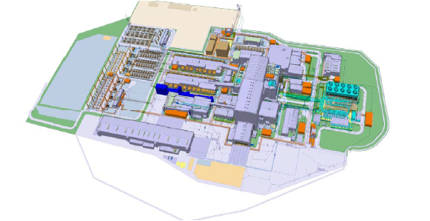
ITER platform
- Scope of Works

The works will consist in the miscellaneous infrastructure including buried piping and networks, mechanical, electrical and Instrumentation & Control (I&C), finishing and retrofit works, these activities could be classified either as Non Protection Important Activity (non-PIA), or as PIA. However this classification is not yet defined and agreed with the Nuclear Operator ITER Organization, each Task Order will specify the list of non-PIA or PIA classification of the associated works.

- General description of the scope of works

The scope of works to be provided by the contractor includes, but is not limited to the following:
- General project management including scheduling, project control and reporting;
- Execution design, manufacturing design, construction, installation and Test & commissioning (T&C) methods;
- Supply of all goods, equipment and materials;
- Construction, installation and Test & commissioning (T&C);
- temporary required means for the performance of the works;
- Coordination and working in coactivity with other contractors working on the area of intervention;
- The provision of all as built documentation including operation and maintenance manuals;
- Implementation of a quality management system.

Works include but are not limited to the following activities:
- Geotechnical Investigations;
- Topographic survey;
- Earthworks (common, rock, excavation and material management, rock face nailing, shotcreting, backfilling etc.);
- Infrastructures works (outside buildings), including (non-exhaustive list) precipitation, industrial and sanitary drainage, outdoor lighting, shallow trenches and galleries;
- Equipment fences and protection, landscaping, parking, road and surfacing, paving, etc.
- Integrated Plant Earthing Grid (IPEG) installation and connection with Qualifoudre certification;
- Piping works, gas or fluid networks (e.g. PBS65 Liquid and gas networks, PBS26 cooling water system);
- Site Networks (electrical, fluids…) with all associated equipment (valves, SDP, manholes, chambers, covers etc.);
- Simple Special foundation and slabs;
- Concrete structures demolition (foundations, slabs….);
- Dewatering, soil treatment;
- Doors, gates, portals (with locks and others hardware – cable, sensors, etc.);
- False Ceiling;
- Partitioning;
- Floor finishing (e.g. Tilling);
- End-user Plumbing, Toilets accessories;
- Signage, tagging;
- Windows;
- Building and tunnels (galleries) services including and not limited to:
  - Piping
  - HVAC (ducting and equipment)
  - Electrical systems and Instrumentation & Control, including cables and cable trays
  - Lighting
  - Lightning
  - Earthing
  - Fire Detection
  - Support system
  - Reprograming of BMS (building management system) / CMSI (Central de mise en sécurité incendie);
- Operation & maintenance of works done by The Contractor or by Others - [Option];
- Miscellaneous services (general logistics) - [Option];
- Coating and painting, and painting touch-ups including after support installation - [Option].

- Location of works:
Works are planned to be done in the entire ITER platform and offices except the Tokamak Complex. Exact location will be defined at the level of specific contracts of OMF-1487.

- Volume of works
The ceiling value of the contract corresponds to C in the following IO-F4E value ranges:

