F4E Market Survey Technical Note
European TBM Program
F4E-OPE-1502
EUROFER97 Material Procurement

1. overview of the Test Blanket Modules (TBM)
The testing of Tritium Breeder Blanket concepts is one of the ITER missions and has been recognized as an essential milestone in the development of a future reactor ensuring tritium self-sufficiency, extraction of high-grade heat and electricity production.
Future fusion reactors will need to re-generate the tritium (T) consumed in the D-T reactions and to extract the thermal power generated by the plasma under economically sound conditions for electricity production. These functions shall be ensured by a so-called tritium breeder blanket covering the inner side of the vacuum vessel and directly facing the plasma.
Within the framework of European fusion strategy, two reference tritium Breeder Blankets concepts are developed to be tested in ITER as Test Blanket Modules (TBMs):
- Water-Cooled Lithium-Lead (WCLL) which uses liquid Pb-16Li as a breeder and neutron multiplier (see Figure 1).
- (ii) Helium-Cooled Pebble-Bed (HCPB), currently renamed in Helium-Cooled Ceramic Pebble (HCCP) concept developed within the frame of EU-KODA Partnership Agreement, with lithiated ceramic pebbles as breeder and beryllium pebbles as neutron multiplier (see Figure 2).
Both concepts use as a structural material Reduced Activation Ferritic Martensitic steel, EUROFER97 (X10CrWVTa9-1). Pressurized water (15.5 MPa, 295-328ºC for WCLL) and pressurized helium (8 MPa, 300-500ºC for HCPB) are used for heat extraction.
The TBM structure is constituted of a box (made of two Side Caps (SC) and First Wall (FW)), stiffened by horizontal and vertical Stiffening Plates (SP) and closed on its back, in the manifold area, with several Back Plates (BP) of different thicknesses with passing through elements, like vertical stiffening plate, horizontal stiffening plates nozzles and inlet/outlet water/He pipes. The TBM manifold system ensures the distribution/collection of the primary coolant (pressurized water or helium) to/from the various parts of the TBM structures, in a way that optimizes the temperature of TBM materials according to their function. Recently, the WCLL and HCCP TBMs design implemented an extended vertical Stiffening Plate, so called “crossing vertical” stiffening concept instead of implementation of Stiffening and Tie Rods used before. This change is illustrated in Figure 1, 2 (right).
Inside the TBM Box, internally cooled Cooling Plates (CP) of HCCP concept and Double Wall Tubes (DWT) of WCLL concept are assembled into breeder units delimited by vertical and horizontal Stiffening Plates. All HCCP structure subcomponents are internally cooled by He circulating in meandering square section channels. Similar concept is used for water-cooled First Wall of the WCLL (SC and SP are not internally water-cooled).
In the rear part of each TBM is located pressurised water cooled neutron and gamma shielding structure made of 316LN-IG austenitic steel (TBM-shield), called together with the TBM box as a TBM-set (see Figure 3).
The tritium released by the breeder material is transported via a slowly circulating Helium purge stream or Pb-16Li flow through the external detritiation units where the tritium is recovered.
The TBM-sets, are structures that intend to be operated inside the experimental reactor ITER, have to fulfil specific requirements of basic nuclear installation (so-called INB, Installation Nucléaire de Base) to assure the quality of design, construction and operation. TBMs, like other ITER in-vessel components, are not part of the first confinement barrier (i.e. vacuum vessel), and are therefore classified as a non-Safety Important Component (non-SIC). Nevertheless, they fall under the highest ITER quality class (QC1) and, as a pressurized nuclear component, also under the scope of the French Decree on Pressure Equipment (PE) and the French Order Nuclear Pressure Equipment (NPE).
The French nuclear code RCC-MRx [Design and Construction Rules for Mechanical Components of Nuclear Installations Applicable to High Temperature Structures and to the ITER Vacuum Vessel, AFCEN, current Edition 2022] has been chosen for European TBMs as the reference code for its development considering the operational conditions such as the irradiation and high temperature environment in an experimental reactor like ITER.
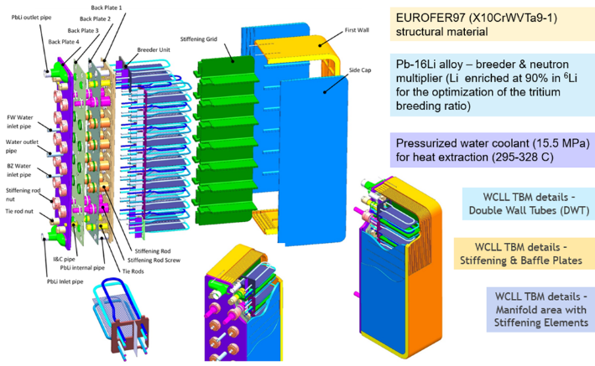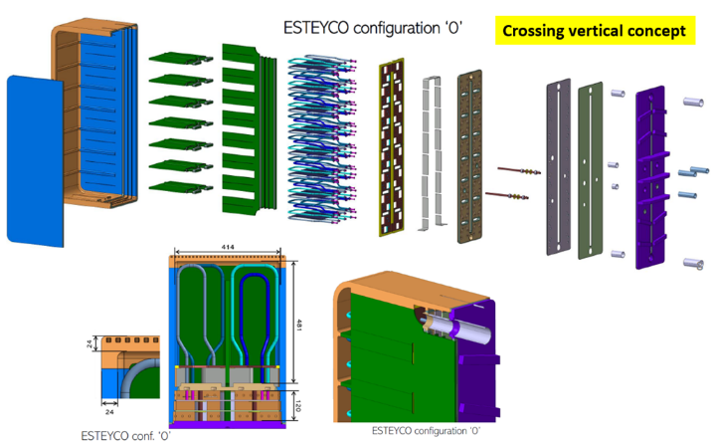
Figure 1: (left) WCLL TBM (global view with breeder unit details and main characteristics); (right) WCLL TBM with implementation of the “crossing vertical” stiffening concept
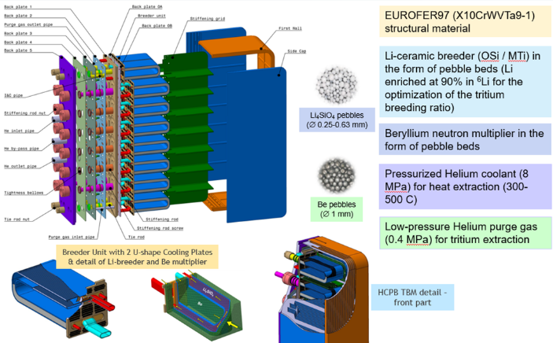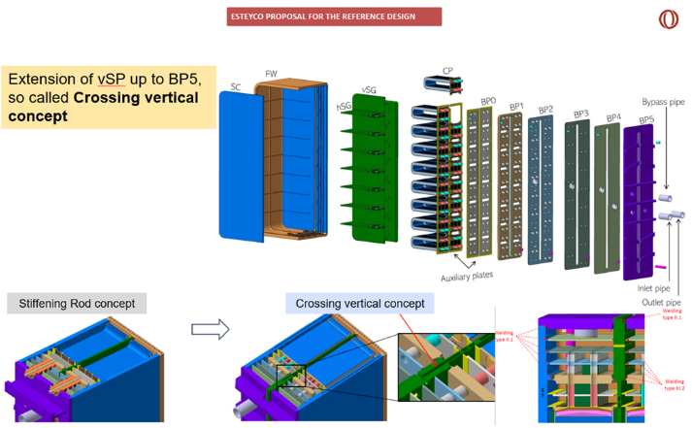
Figure 2: (left) HCCP (HCPB) TBM (global view with breeder unit details and main characteristics); (right) HCCP (HCPB) TBM with implementation of the “crossing vertical” stiffening concept
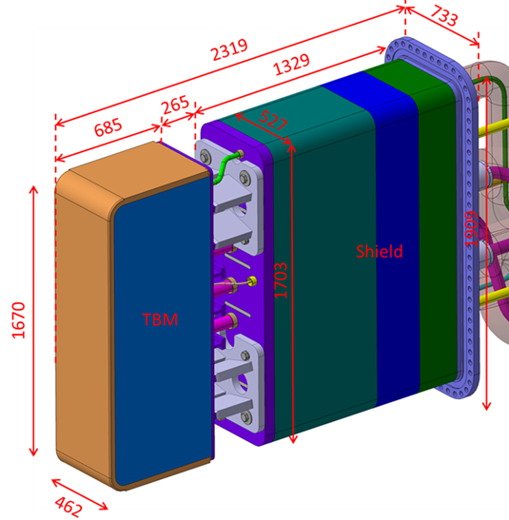
Figure 3: TBM-set with indicative dimensions (for illustration only)
Development of the TBMs fabrication technologies, their standardization and qualification are needed before the HCCP and WCLL TBM-sets manufacturing and delivery to ITER site. Two phases are envisaged in this process:
- 1st phase (to be implemented within 2021-2026, i.e. currently on-going), focused on the proof of the TBM-sets fabrication and assembly processes feasibility; this task is addressed in the Framework Contract (FwC) F4E-OMF-1070-01 which was awarded to the European consortium CEA and FRAMATOME in 2021 and its implementation is envisaged for ~5 years.), and
- 2nd phase (to be implemented within 2025-2031), focused on the TBM-sets manufacturing and delivery, including qualification of the used Welding Procedure Specifications (WPS) following the Code & Standards requirements.
All the TBMs-related fabrication developments are made of EUROFER97 steel material. In total, 87 rolled plates and 3 billets/bars of the amount of ~29 tons were delivered within the latest batch #4 procurement of EUROFER97-4 steel material (see Figure 4). This material is used for TBM’s fabrication feasibility development studies, namely, development of preliminary Welding Procedure Specifications (pWPS), fabrication of feasibility mock-ups and complementary studies (e.g. EUROFER97 weldability demonstration, effect of multiple Post-Weld Heat Treatment (PWHT) operations, etc.). In addition, EUROFER97 steel products are used for an additional characterization of mechanical properties of base material and weld joints, including their properties under neutron irradiation, aiming at including them in the EUROFER97 material properties database of the RCC-MRx code.
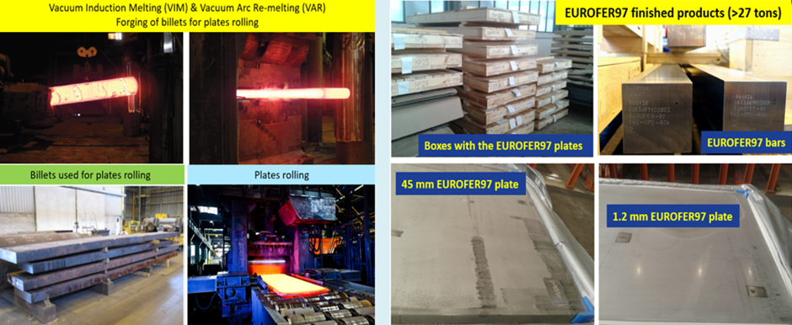
Figure 4: Fabrication of EUROFER97-4 (batch 4) steel products – plates and bars

F4E EUROFER97-5 steel material needs
- Currently, procurement of a fifth batch of EUROFER97-5 steel material is under preparation with the target to publish a Call for Tender by end of 2023 with the material delivery in ~2025/2026 (Procedure F4E-OPE-1502). This material is going to be used for further fabrication development studies, in particular, for qualification of Welding Procedure Specification (WPS) to be used at TBMs’ manufacturing process. The estimated amount of that EUROFER97-5 products is about ~20-30 tons, consisting of plates of various thicknesses (with max. thickness up to 50-55mm), bars (with squared cross-section of 100-150mm) and tubes.

- Another procurement of EUROFER97 material for manufacturing of the first TBMs, to be delivered to ITER, is planned for ~2027/2028. The estimated amount of that EUROFER97 to be procured is about 20-30 tons, consisting of the plates, bars and tubes.

2. Material specification
- EUROFER97 is a Reduced Activation Ferritic-Martensitic (RAFM) steel (X10CrWVTa9-1), developed based on conventional 9Cr-1Mo steel used in fission, where some highly activating alloying elements, like Mo and Nb are replaced with W and Ta offering lower neutron activation. Moreover, highly activating impurities, like Nb, Mo, Ni, Co, Cu, Al, Si, are reduced to the lowest content that is technically achievable at reasonable cost. (Note: The fusion reactor structures made of EUROFER97 steel shall return to “low-level” radiation waste after 80-100 years, considering ~6 years of exposure in the reactor.)
- The EUROFER97-5 finished products shall be produced following the specification and requirements set up in the RCC-MRx construction code where, since 2012 Edition the EUROFER steel is introduced under Section III, Tome 6: “Probationary Phase Rules in section RPP4-2012-EUROFER” - RM 243-3, “G-RPS: X10CrWVTa9-1 alloy steel plates, 1 to 50 mm thick”.
- The EUROFER97-5 finished products to be procured consist of the following items:
  - plates of various thicknesses with max. thickness up to 50-55mm (plate thickness according to standard EN 10029, class C), plate width: 1000mm ± 20.0mm, plate length: 2300mm ± 200.0mm; detailed list of plates’ products will be specified in the Call for Tender
  - billets/bars with a squared cross-section of 100-150mm with tolerance of ±3%, bar length: 4000mm ± 50.0mm; detailed list of bars’ products will be specified in the Call for Tender
  - tubes of approximate diameters Ø10.5x1.25mm and Ø13.5x1.5mm; detailed list of tubes will be specified in the Call for Tender.
- The procurement requirements for EUROFER97 steel chemical composition, mechanical properties and mechanical properties tests are presented in Table 1, 2 and 3 below.
- Moreover, the EUROFER97 structure shall be homogeneous and tempered martensitic; the delta ferrite content must not exceed 3% (AMS 2315). The presence of primary carbides is not permitted. The grain size index measured according to RMC 1351 [RCC-MRx] must be greater than or equal to 8 for the plates and greater than or equal to 6 for the bars. The non-metallic inclusion rate as per RMC 1352 (ASTM E45 – Method A) must be less than 1 for type A, B, C and D inclusions. Hardness according to RMC 1280 [RCC-MRx] must be between 200 and 240 HV 30 (3 points minimum).
- The products volumetric examination shall be performed with an ultrasonic examination as per NF EN 10160. The scanning plan and criteria are those of levels S2 and E3 of the standard.
- Prior to commencement of manufacturing operations/process the supplier shall draw up a Manufacturing Programme which shall include the following operations presented in a chronological order:
  - Identification of the specification for a raw material assuring the required steel purity (supplier, type, process of fabrication and requirements)
  - Melting process
  - Weight and type of ingot used
  - Top and bottom end discard percentages
  - Forging, hot and/or cold rolling steps (degree/temperature, duration), indication of the main rolling directions
  - Conditions for intermediate heat treatments and final Heat Treatment for Mechanical Properties, in particular, temperature (normalization/quenching at ~940-980°C and tempering at ~740-760°C), holding time and cooling method
  - Position of acceptance test samples on the plates, bars and tubes (mechanical properties, structure and grain size, surface examination – surface defects, volumetric examination)
  - Dimensional drawings with position of test specimens on the samples
  - Tolerances for the products dimensions
  - Cleaning method to be used for the products
  - Packaging method to be used for the products
  - Detailed schedule for the manufacturing and testing/examinations with the main milestones.
- The Manufacturing Programme shall be presented to F4E and F4E shall, after its approval, issue an Authorization-to-Proceed with the manufacturing operations/process.
- Materials shall be supplied together with the type 3.1 Inspection certificates according to EN 10204.
- A Test report shall be delivered by the supplier together with the Inspection certificate, including the following information:
  - The heat number and plates/bars/tubes reference numbers
  - Manufacturing operations/process description as-implemented, following the Manufacturing Programme
  - A ladle chemical analysis and products analyses results
  - Micrographic examination results
  - Mechanical tests results
  - Non-destructive examination results
  - Defect mapping
  - Dimensional check results
  - Cleaning method used and packaging of the products
  - Temporary storage conditions.
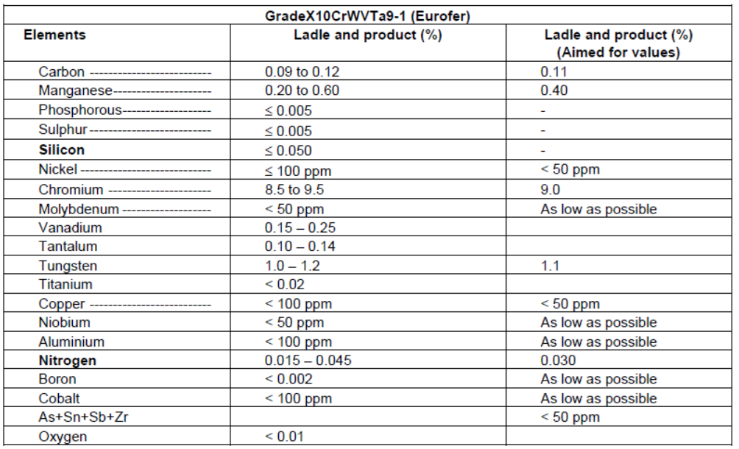

Table 1: EUROFER97 chemical composition (in wt%) (table RM 243-3.31 [RCC-MRx code])

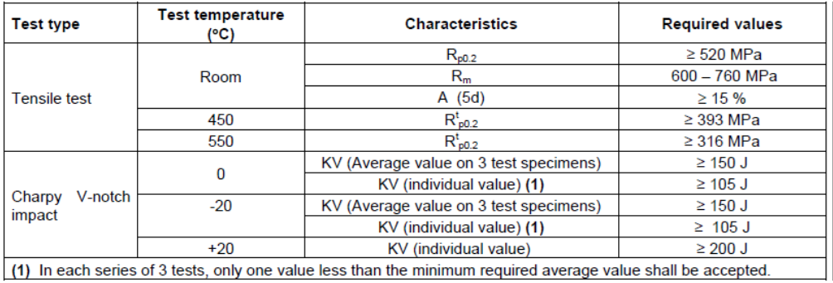
Table 2: EUROFER97 mechanical properties requirements (table RM 243-3.51 [RCC-MRx code])
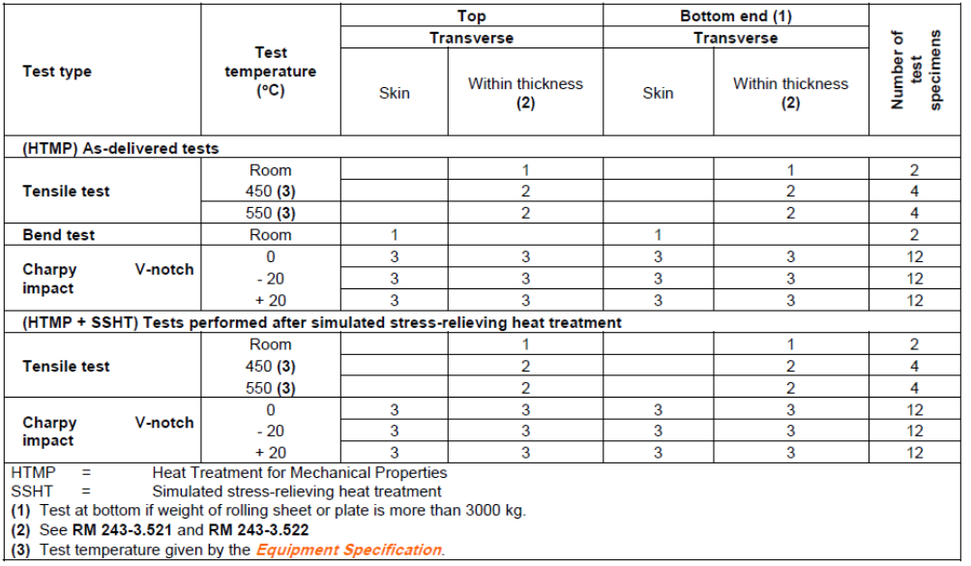
Table 3: EUROFER97 – number and content of tests on mechanical properties for “As-delivered tests” (table RM 243-3.531 [RCC-MRx code])

3. Market Survey
- F4E is looking for the EUROFER97 finished products supplier(s) able to supply the plates of various thicknesses (with max. thickness up to 50-55mm), billets/bars (with a squared cross-section of 100-150mm), and seamless tubes (of approx. diameters of Ø10.5x1.25mm and Ø13.5x1.5mm). (Note: Please note that the indicated geometrical characteristics are tentative, just for an information. Detailed list of the EUROFER97-5 products will be specified in the Call for Tender.)
- The supplier(s) shall manufacture, test, examine, mark/identify, clean and pack the EUROFER97 finished products following the RCC-MRx requirements and specification, in particular, in terms of:
  - chemical composition, including level of impurities
  - final heat treatment consisting of normalization/quenching and tempering steps, where the maximum allowable deviation from the nominal holding temperature shall be ±10°C for all points in the plate/bar
  - products’ mechanical properties (tensile, impact fracture, hardness), assuring their homogeneity across the finished products
  - products’ microstructure and grain size
  - products’ dimensions

- The supplier(s) may need to develop/determine optimal parameters for the products heat treatment process , in particular, the duration of the tempering stage must be determined as a function of the plate/bar thickness) ensuring homogeneity of the mechanical properties across the finished products.

- With this market survey, F4E is interested to know about:
- Availability of Industrial actor(s) to manufacture and supply the specified EUROFER97 products with characteristic described in section 2, including the EN 10204 type 3.1 Inspection certificates and related Test report.
- The current estimated date for the F4E call for tender publication is 4Q-2023, and the delivery of the EUROFER97-5 finished products is expected in 2025/2026.

