Barcelona, 23rd November 2023

Sale by Fusion For Energy of instruments GapGun® Pro, Absolute Scanner LAS-20-8 (without controller), and AICON MoveInspect XR8 System with accessories

Due to a technical need for procuring newer models of the same instruments, the F4E Metrology unit has decided to resell three of its used model instruments. You can buy only part of the package.
Here a resuming table:

Brand | Instrument | Status | F4E price € | Your bid €
Third dimension | GapGun® Pro device – Data Collector Handle Pro + Head sensor – plus series FOV7/M + accessories | Bought in 2015 calibration up to 14.08.2024 | 25000 |  | 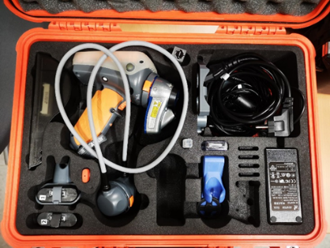
Hexagon | Absolute Scanner LAS-20-8 without controller and connection cable. | Bought in 2016 calibration up to 21.02.2024 | 30000 |  | 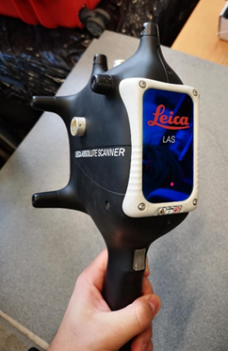
Hexagon | Movieinspect XR8 with accessories and 6DOF probe | Bought in 2018 calibration up to 01.15.2020 | 35000 |  | 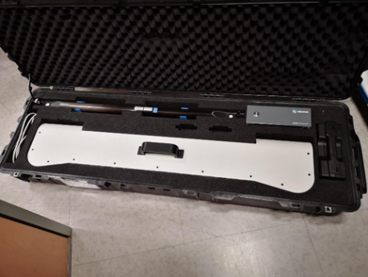
Make your best offers.

In case of interest, please contact: michaela.trbolova@f4e.europa.eu and abdelouahab.elmiadi@f4e.europa.eu .

GapGun® Pro
Under the contract F4E-OPE-0554, F4E has purchased the GapGun® Pro with its accessories.

Qty | Product ID | Brand | Description
1 | 3DSW-144715 | Third dimension | GapGun® Pro device – Data Collector Handle Pro

The following accessories are included with the instrument:
Qty | Product ID | Brand | Description
1 | 3DSW-144563 | Third Dimension | Head sensor – plus series FOV7/M
1 | 3DSW-144265 | Third Dimension | Deck Dock assembly
1 | 3DSW-133630 | Third Dimension | Battery housing, clip-on battery pack
1 | 3DSW-133280 | Third Dimension | Calibration Pin Gauge
1 | GG14-6576 | Third Dimension | Cable, head extension, Vchange
1 | GG14-0321 / IE121391 | Third Dimension | Battery charger - EU
1 | GG04016 / 21137 | Third Dimension | Power converter 12v – for Desk dock
1 | GG04017 / 21137 | Third Dimension | Power converter 24v – for Charger
2 | GG11-239 / IE134513 SN3992  GG11-239 / IE133613 SN3395 | Third Dimension | Battery
1 | GG11-263 | Third Dimension | Artefact, Hexagonal - GG plus series
1 | GG14-7506 | Third Dimension | Power lead pack, EU (C13, C7)
1 | GG13-842 | Third Dimension | Orange 2M CAT5e Straight Patch Cable
1 | GG10-154 | Third Dimension | Waist fixation system
1+1 | GG13-549 | Third Dimension | Anti-static brush
1+1 | 3DSW-144563 / 3DSW-133280 | Third Dimension | Documents – Certificates of calibration

The price paid by F4E for the supply of the GapGun® Pro was 40,649.00 EUR. To be noted that this price included a software license for SPC3d v7.2, Calibration and Support services and GapGun training. Individual prices are not assigned in the invoice from the supplier.

Technical specification for GapGun device MX+ WIFI with the associated sensor head FOV07/M:
Measurement:
- Field of view: 6.5 mm
- Resolution Enhancement Technology (RET): 3 μm
- Practical resolution in customer-based conditions: 10 μm
- Repeatability: Proven to < 15% QS9000-MSA
- Operating principle: Laser triangulation with Resolution Enhancement Technology

Measurement head:
- Weight: 170 g
- Dimensions: 50 x 41 x 105 mm (W x D x H)
- Laser: Class 2M with automatic laser intensity adjustment
- Standoff: 20 mm from front of head for super High-resolution head.

Handle:
- Weight: 460 g
- Dimensions: 76 x 117 x 165 mmm (W x D x H)
- Storage: Minimum of 1GB
- Screen: 89 mm, daylight readable full colour touchscreen 240 x 320 pixel

System:
- Environmental: IP50
- Operation: 0 - 40°C
- Storage: -10 - 40°C

The device is supplied with its accessories:
- Pack connection LAN/WIFI
- Precision artefact with traceable calibration,
- Connection cables, locking belt clip and belt, and wrist loop.
- 2 batteries (autonomy 6h)
- Electronic charger
- Internal battery
- Flight grade storage case with custom insert designed to house all accessories.

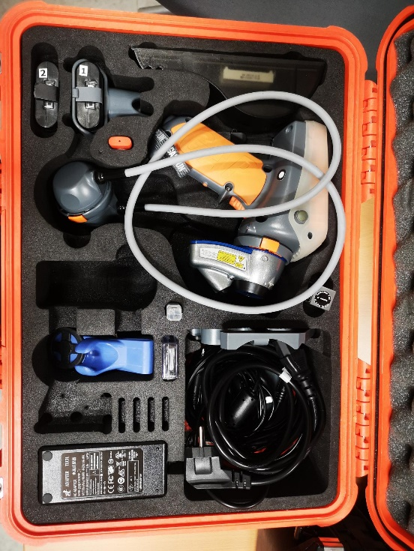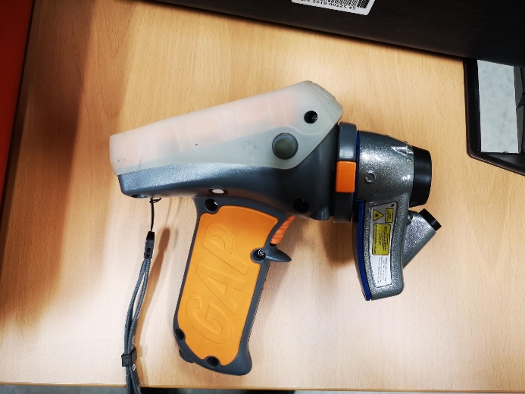

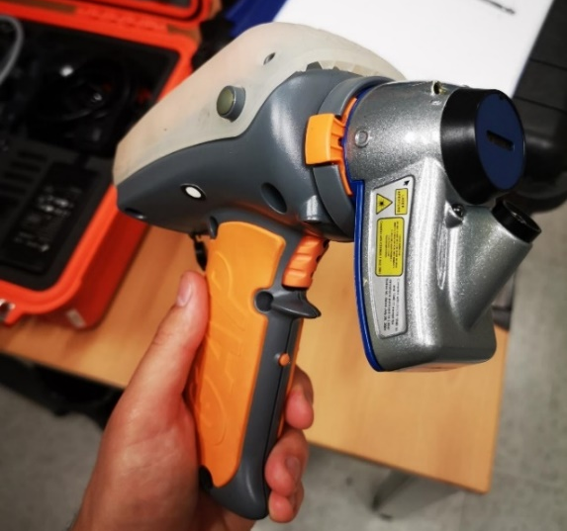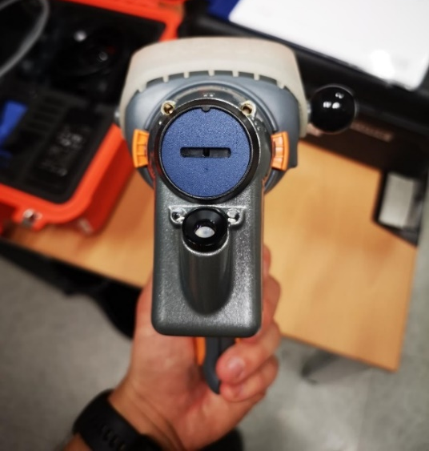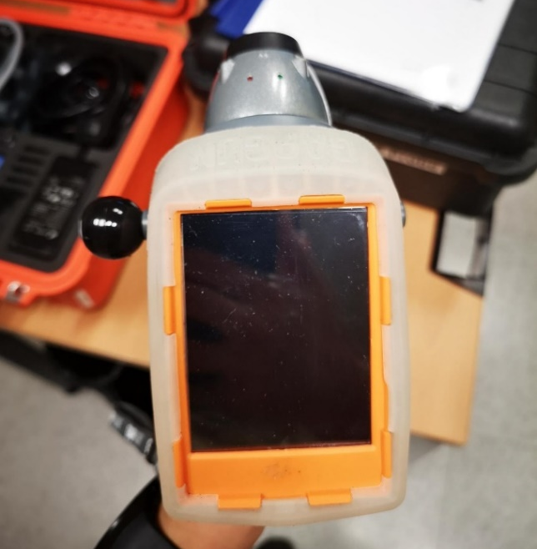

Absolute Scanner LAS-20-8
Under the contract F4E-OMF-0902-01-01, F4E has purchased from Hexagon an Absolute Scanner LAS-20-8.

Qty | Product ID | Brand | Description
1 | LAS-20-8  (s/n 745306) | Hexagon | Absolute Scanner LAS-20-8 (without controller)

The price paid by F4E for the supply of the LAS-20-8 was 66,240.00 EUR. To be noted that this price was for a set of Absolute scanner LAS-20-8 and Absolute scanner LAS-XL. Individual prices are not assigned in the invoice from the supplier.

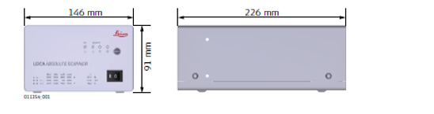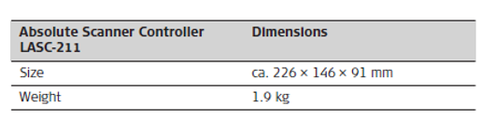
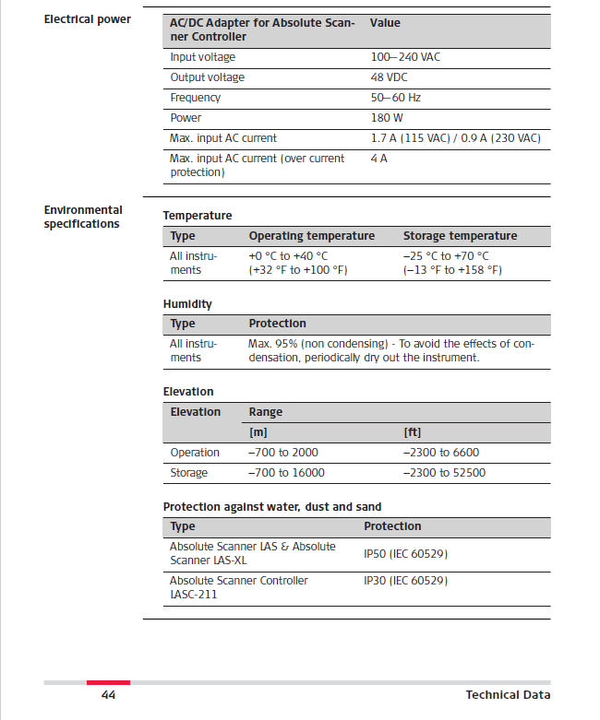
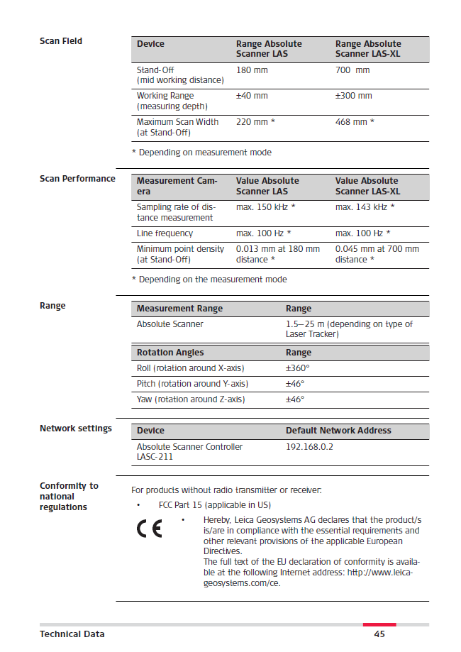

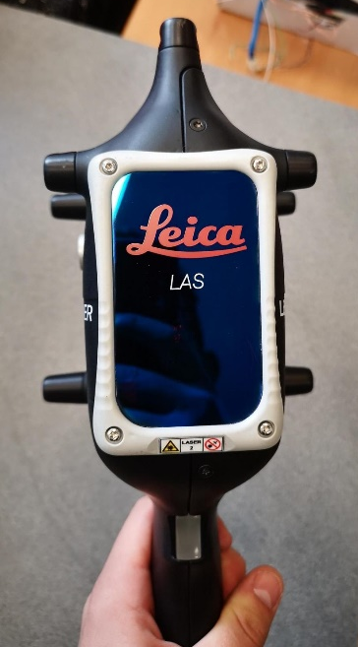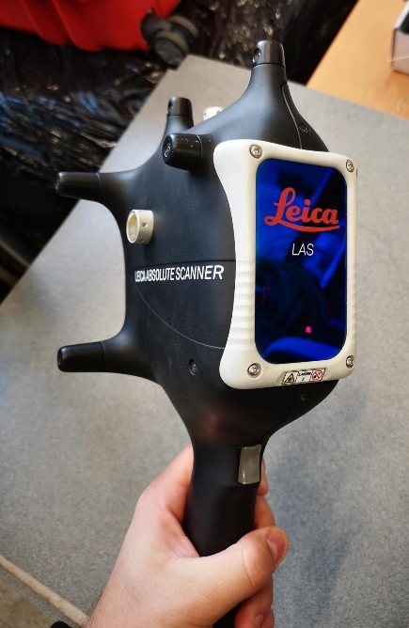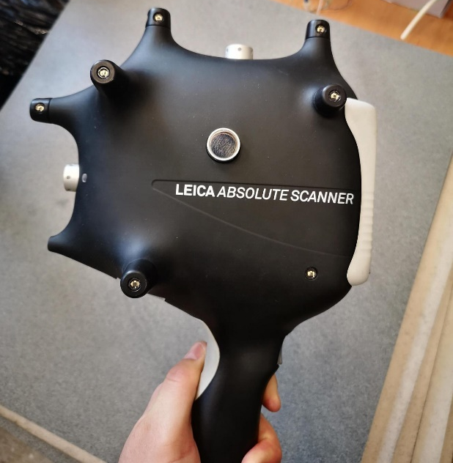

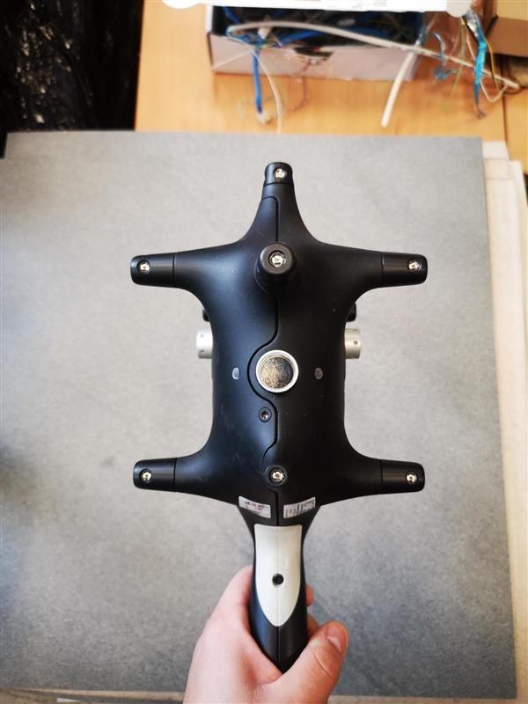

AICON MoveInspect XR8 System
Under the contract F4E-OMF-0902-01-02, F4E has purchased from Hexagon a MoveInspect XR8 System.

Qty | Product ID | Brand | Description
1 | ART109363 | Hexagon | AICON MoveInspect XR8 System with accessories

The following accessories are included with the instrument:
Qty | Product ID | Brand | Description
1 | ART106043 | Hexagon | MoveInspect XR8 sensor set
1 | ART101182 | Hexagon | Probe set for MoveInspect XR8
1 | ART109908 | Hexagon | AICON MoveInspect XR8 tripod

The price paid by F4E for the supply of the MoveInspect XR8 System was 63,330.00 EUR.
The instrument and its accessories are brand new and have never been used.

The AICON MoveInspect XR8 consists of a camera beam with two high-resolution eight-megapixel digital cameras. Its calibrated cameras are equipped with invisible flashes that eliminate dependence from environmental lighting, and capture any type of target, either on the component to be measured or on the hand-held probing device AICON MI.Probe.

The generated images are processed automatically; 3D data are calculated in real time. Based on the renowned AICON MoveInspect Technology, the XR8 is the only technology able to simultaneously capture multiple points. This makes the system significantly faster in many applications, and therefore capable of offering important time and cost savings.

The MoveInspect software determines the 3D coordinates of object points or the 6-DOF (Degree of Freedom) data of solid bodies at any time. The system’s ruggedised housing makes it suited to almost any industrial environment.

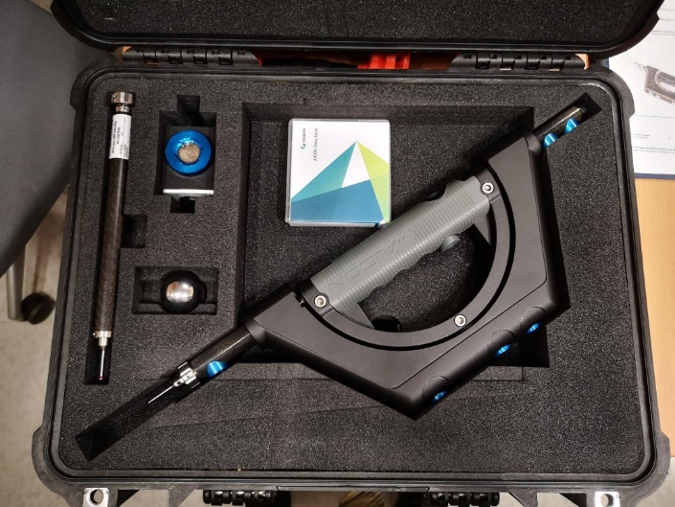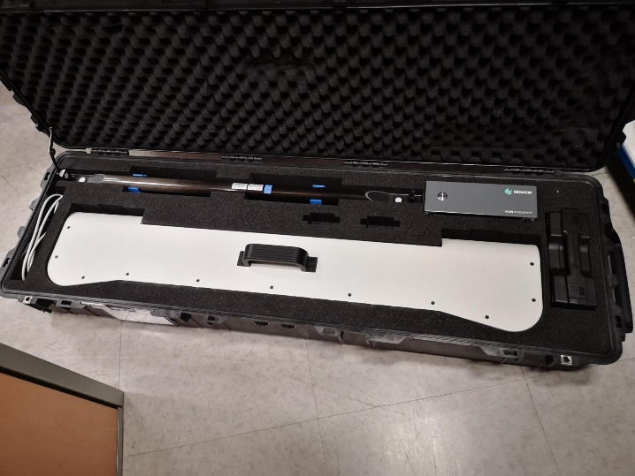

Under the contract F4E-OMF-0902-01-01, F4E has purchased from Hubbs through Metromecanica accessories SBW-1.500-12mm for the MoveInspect XR8 System.

Qty | Product ID | Brand | Description
5 | SBW-1.500-12mm | Hubbs | 1.5” Half sphere white tape

The price paid by F4E for the supply of the half spheres was 759,50 EUR.

In case of interest, please contact: michaela.trbolova@f4e.europa.eu and abdelouahab.elmiadi@f4e.europa.eu .

