ITER NEW RF HEATING BUILDINGS MARKET SURVEY TECHNICAL NOTE

Purpose

This note provides a short description of the five new Buildings/ Bridges and Infrastructures on the ITER platform required in the frame of the new Iter baseline development and the associated need for additional Plasma heating capacity.
- New cooling water building B63.
- New ECH building B18.
- New ECH TL bridge K2.
- New ICH building B20.
- New ICH TL bridge K3.

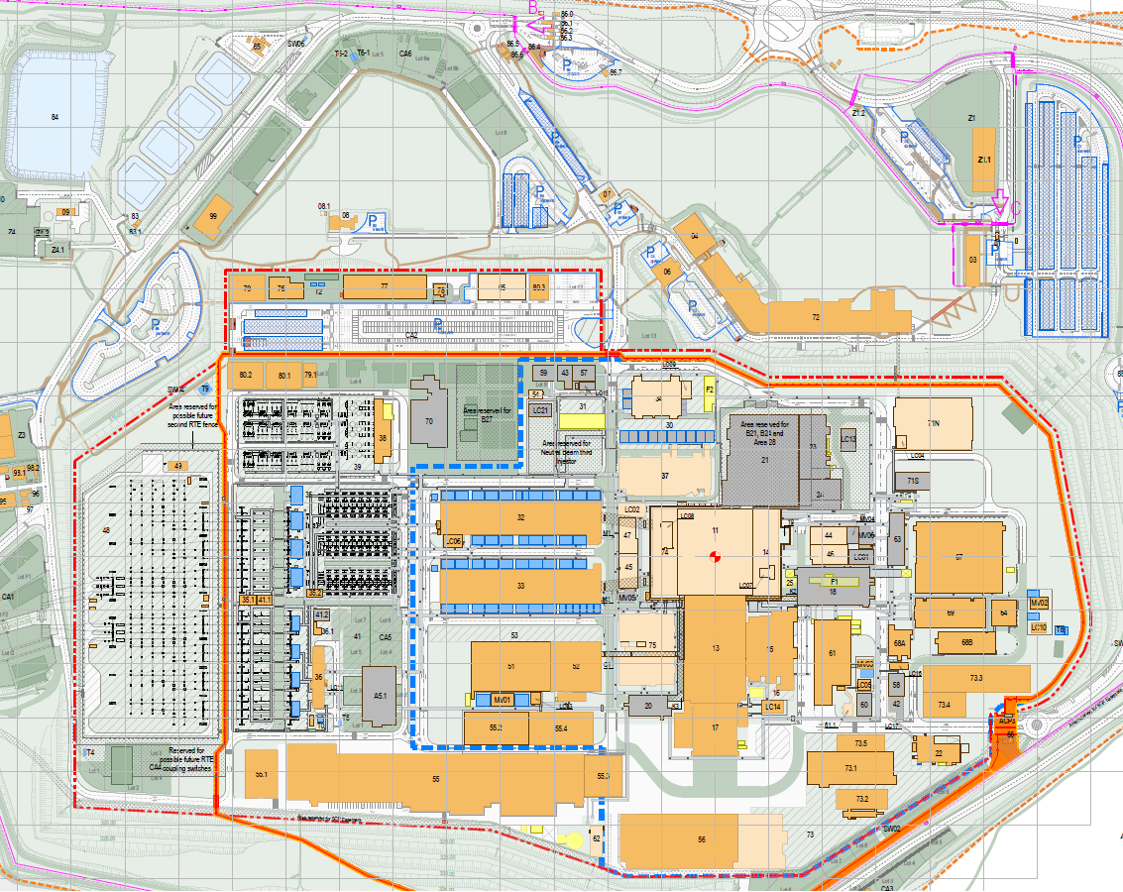
New buildings location
Site Entrance
Figure 1: ITER Worksite plan view
Figure 2: New buildings location plan view

The intended call for tender will focus on civil and finishes works (concrete , metallic works, doors, earthing, infrastructures works connection, building rain water drainage, cast in networks, partitioning, structural fire protection, false ceiling, false floor,..), infrastructure works excluding micro piles for B18 and some external networks that would be performed before contract award by others and the building services that would be subject to an IO call for tender.

Notes:
- Direct nuclear experience on Protected Important Activities (PIA) activities is not required for this call for tender.
- Tenderers shall have experiences in execution design, building construction works in industrial complex environment: limited space and strong co-activities, writing & implementing relevant construction methods statements, and a strong Health & Safety policy supported by excellent safety performance ratios.
- Tenderers shall have experiences within an international environment
- Tenderers shall have a strong Quality and Management system in place, and shall be qualified ISO 9001 or similar,

Schedule of works
The contract for the execution of works, three building and two bridges, is foreseen to start early 2027 for a total duration of 2.5 years.

Overview of Buildings

ECH Building B18

This building will house Heating system and shall be located at the east of B14 (refer figure 2), and between B46 in the north and B61 in the south.
The overall building dimensions are 66.0 m in length, 33.0 m in width and 19.8 m in height. This building has three levels on its north side (part of L1, L2 and L4) and two levels on its south side (part of L1 and L3). The building also has a partial basement B1 of 88.9 m long x 20.1 m wide x 4.0 m height.
The building is partially laid on the ground and loading micropiles foundations.
Structurally it is made of the concrete slabs, beams and columns, and a metallic roof and bracing.
Rooms are separated by partition walls made of plaster board or similar.
Out of the scope
The B18 basement is surrounded on its North side by two galleries and on its south side by one gallery. The Level 1 slab is in cantilever on the galleries.
Figure 3: General layout of Building B18
Nota: micro-piles are out of scope but their connections with main structures are within the scope

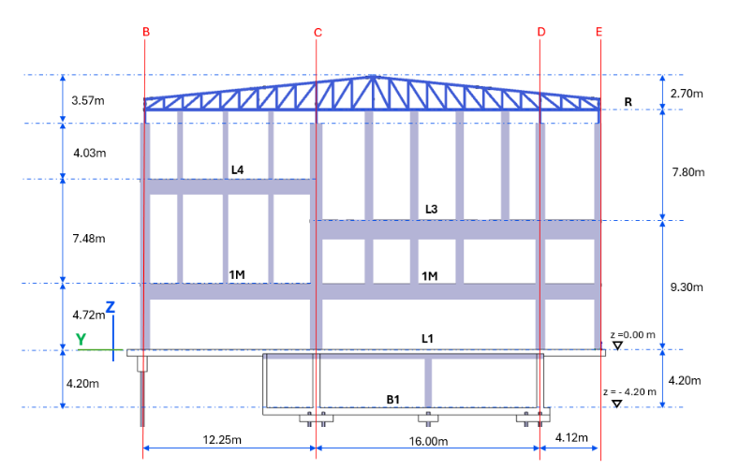
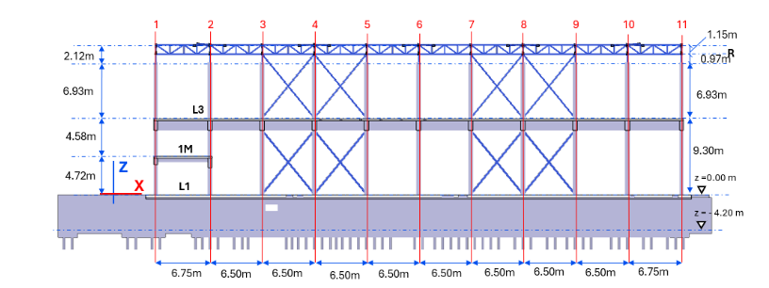
Figure 4: Cross sections of Building B18

Roofing and cladding are made of metallic element, including thermal/fire insulation, fixed on primarily structure with secondary elements.

ECH TL Bridge K2

The ECH TL (Transmission Line) Bridge will connect building B18 to building B13. This bridge is housing transmission lines.
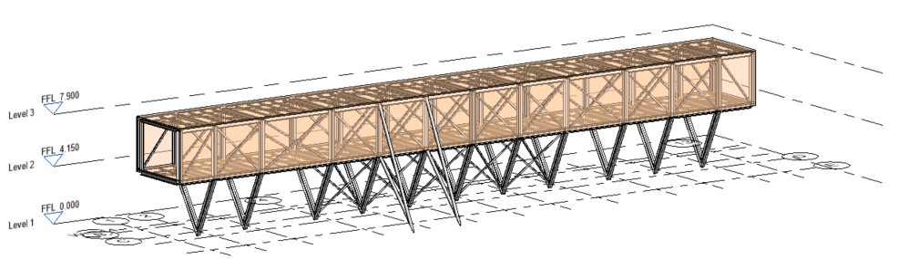
Figure 5: General layout of K2 bridge

The bridge is divided into two parts with an expansion joint in between:
▪ The western part, anchored on the B14 façade, and supported on the south retaining wall of the SIP, is 30 meters long.
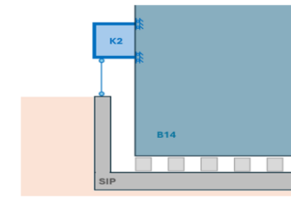
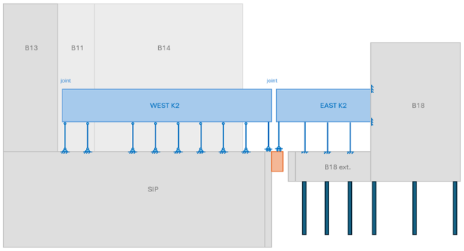
▪ The eastern part, linked to B18, anchored on the B18 basement wall, is 18 meters long.
_A-A
A
A

Figure 5: General layout of K2 bridge
The structure of about 4m x 4m section, is made of steel-trussed beams. These frames are repeated every 3.7 meters in the longitudinal direction with Saint Andrew’s crosses bracing the inclined planes.
The bridges facades and roofing are made metallic elements and thermal insulations.

ICH Building B20

The building will be located at the West of B17, in the South of B75 (refer figure 2 above).
It is a reinforced concrete structure with overall dimensions of 36.8 m in length, 18.9 m in width and 23.5 m in height. The roof and building bracing are made of metallic frame works.
The building is resting directly on the ground through the lower slabs of the underground level.
This building consists of three superstructure levels (L1, L2 et L3) and a basement (B1) with a clear height of 3.3 m. Rooms are separated by partition walls made of plaster boards or similar.
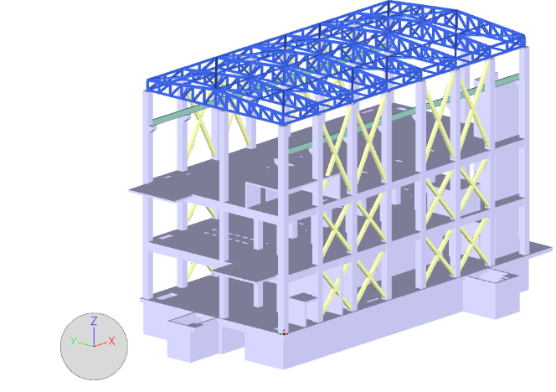
Figure 6: General layout of building 20
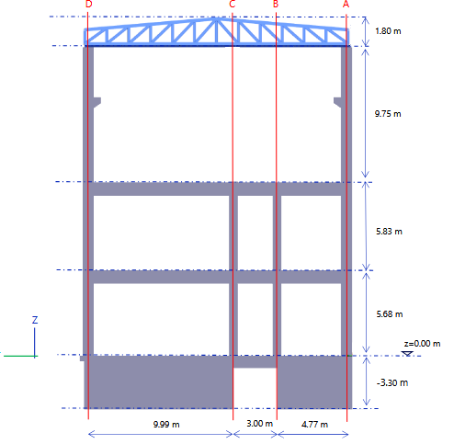
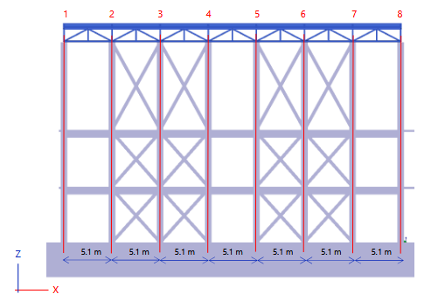
Figure 7: Building 20 cross sections.

At B1 level the building includes a basement traversed in the longitudinal direction by an existing gallery and in the transvers direction by another piece of gallery scheduled for demolition. The basement footprint measures approximately 36.3m length and 18.4 m in width, with a clear heigh of 3.3m.
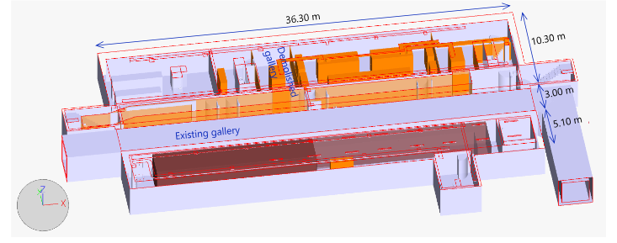
Figure 8: B20 basement

Roofing and cladding are made of metallic element, including thermal/fire insulation, fixed on primarily structure with secondary elements.

ICH TL Bridge K3

The bridge will connect the new buildings B20 to B13. It enables the routing of transmission lines.
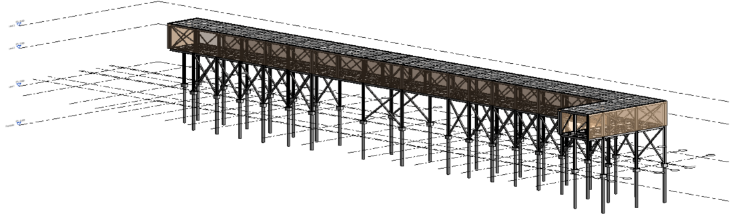
Figure 8: Global view of the bridge K3

The bridge is running all along the west fade of B13 and will be located below the existing bridge and above the road.
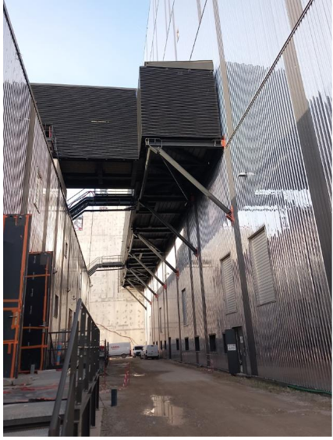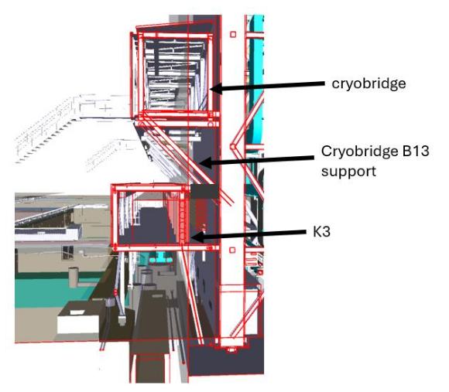
Figure 9: Picture of the cryo-bridge (left) and future bridge K3 underneath existing bridge (on the right)

The bridge structure is a steel frame, and the dimensions are the following:
- Total Length: 83.7m
- Box width: 3.9m
- External column high: 5.25m
- Box height: 3.45m
- Total Height 9m

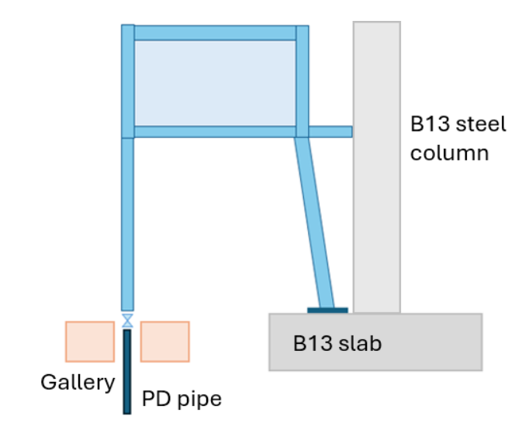
Figure 10: Cross section on the bridge K3

Roofing and cladding are made of metallic element, including thermal insulation, fixed on primarily structure with secondary elements.

ECH Building B63

The building B63 is located Northeast of building B18, its dimensions are 48m long, 15m wide and 14.5m high (from ground level).
The building has two main levels and mezzanines.

Building foundations are designed to be micro-piles and beams which depth total depth is 8m from ground level as well as independent foundations for rotating machines.
The superstructure is a steel structure with partition walls made of plaster boards or similar.

Roofing and cladding are both made of metallic elements, including thermal insulation, supported by secondary structure attached on the primary one.

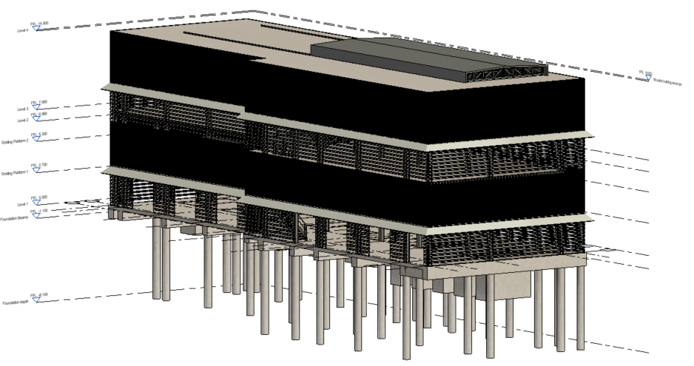
Figure 11: Global view of building B63

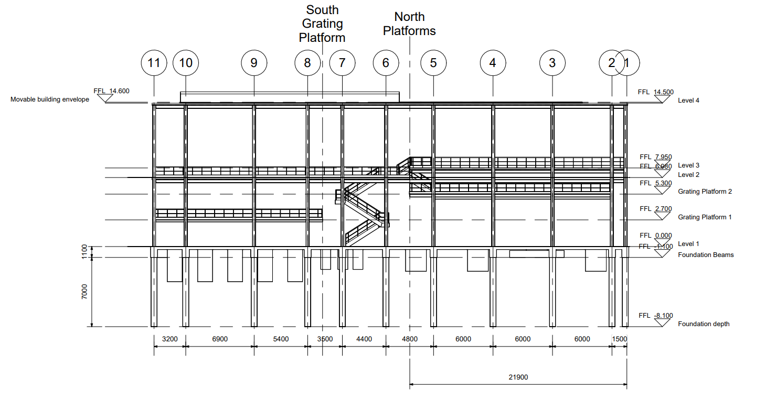
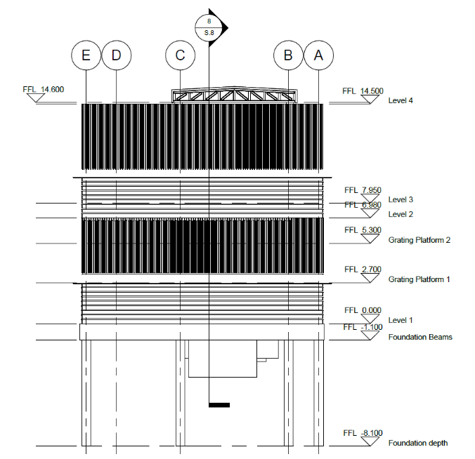
Figure 12: Vertical section of building B63

Infrastructures
The infrastructure works can be defined within each area:

B20 Area:
Preparation works:
- A small tunnel made of precast elements linking two tunnels will need to be dismantled and the openings closed

Final works:
- A road reshaped at the North of B20.
- A road to be implemented at the South of B20, between B20 and future extension.

B18 Area:
Preparation works:
- Before civil works of B18, some networks will need to be temporarily rerouted and definitively installed once the basement will be finalized (industrial/sanitary drainage (vacuum networks)).
- Two opening on existing tunnel on the South shall be performed.

Final works:
- A road reshaped at the South of B18.

B63 Area:
Preparation works:
- Before civil works of B63, some networks will need to be rerouted (industrial/sanitary drainage (vacuum networks) and water networks) in order to ease the cooling water pipes to be installed from B18 to B63
- A relocation of a rainwater manhole.
- Two openings on existing tunnels on the South of B63 shall be performed (cooling water and electrical tunnel)

Infrastructure works for cooling water supply:
- The cooling water pipes linking B18 & B63 need to be installed on the buried part from B18 up to crossing the road on the East (excavations in green below)
- The cooling water pipes linking B18 & B63 require a rack structure from B63 to the South. This structure supports the pipes going to B18 and the supply/return pipes coming from Eastern area (rack in red below)
- The cooling water pipes providing supply/return water from Eastern area require foundation to be installed all along their routing (foundations in orange below)

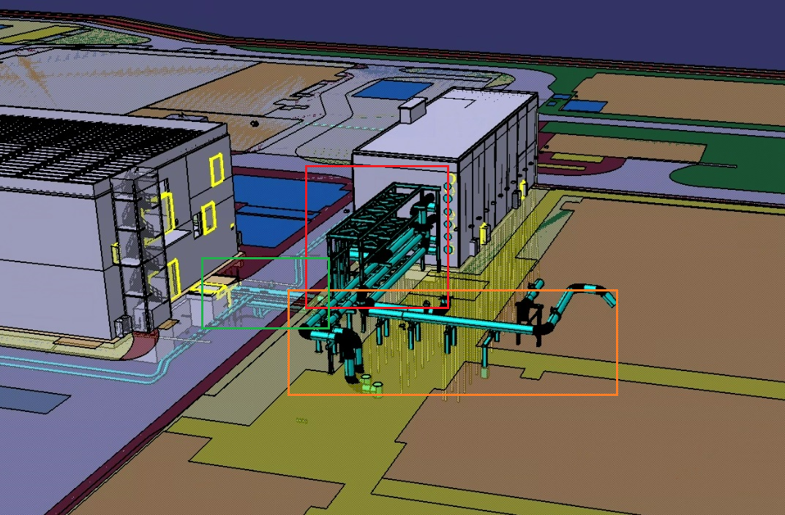

Final works:
- A road reshaped at the North of B63.

Common works for all areas:
- Before building civil works, some networks will have to be dismantled
- Closures of existing tunnels and rainwater drainage collectors.
- The definitive connections will need to be implemented for each building (drainages, liquid and gas supply).
- Roadworks/adaptations to be performed all around each building

You can answer to the F4E/IO short Market Survey here:
https://ec.europa.eu/eusurvey/runner/ITER_RF_HEATING_BUILDINGS

