Collective Thomson Scattering (CTS) front end. Summary of Procurement needs.

Introduction to the system
The CTS is an ITER diagnostic system whose principal function is to measure the fast-alpha particles resulting from fusion reactions. The CTS front-end can be divided up into three main sub-systems: the launcher line, the receiver lines, and the auxiliary system.
The purpose of the launcher line of the CTS is to propagate and launch a microwave probe beam into the ITER plasma at a power of at least 1 MW and a frequency of 60 GHz.
The receiver lines will route the scattered signals, from the measurement volumes within the ITER plasma. The received microwave radiation will be coupled into overmoded circular corrugated waveguides, using quasi-optical mirrors.
The auxiliary system transmits a calibration signal to the main receiver mirror and emits it there, as well as transmitting the microwave “sniffer” probe signal(s) from the second launcher miter bend mirror to the receiver electronics.
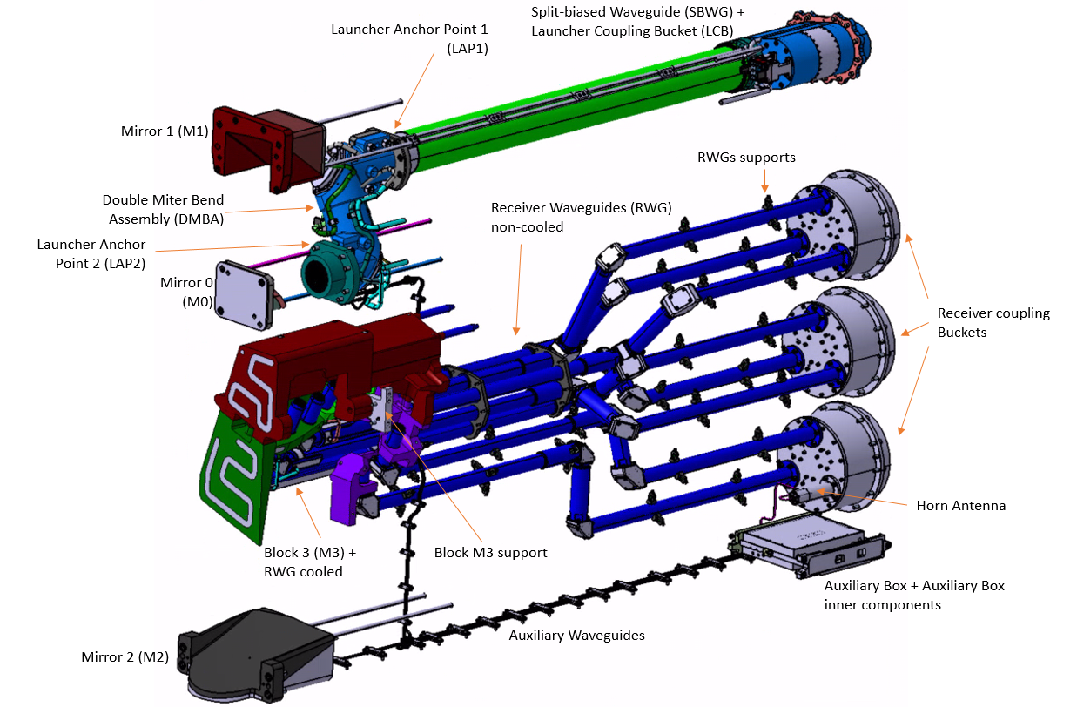
  - CTS front-end general view

Scope of the work:
The goal of this related forthcoming F4E contract is to demonstrate the readiness for manufacturing, to manufacture and/or to procure all CTS front-end components, and to perform all the necessary assembly and testing activities at the factory to validate the compliance with the system requirements. The scope also includes the assistance to site acceptance tests.
Activities of management, requirement verification, follow-up of codes and standards and QA activities, are also included. The scope is divided in the main Work Packages (WP) listed below:
- Preparation for manufacturing.
  - Raw material supply specifications and supply of the raw material in advance
  - Refinement of the manufacturing design to adapt the design to the suppliers´ expertise inside fixed boundaries.
  - Critical processes qualification (For Hot Isostatic Pressure bonding – HIPing -, brazing and lid welding at least).
  - Manufacturing and Testing Readiness assessment. Production of the full package to demonstrate the feasibility of manufacture and testing meeting the requirements.
  - Manufacturing Readiness Review (MRR) and Test Readiness Review (TRR)
- Procurement, Manufacturing and Inspection. Activities necessary for purchase, qualification, manufacturing, intermediate and final cleanings, assembly and intermediate testing of components and sub-assemblies.
- Marking, Cleaning, Assembly and Factory Acceptance Testing. After marking and cleaning, the necessary assembly/disassembly preparation and execution of the factory acceptance tests have to be executed at the Supplier’s factory for requirements verification prior packing and delivery.
- Labelling, Packaging, Transport and Delivery (inc. Advise of Delivery -AoD). All necessary disassembly, assembly, labelling and packaging of the CTS components to be ready for delivery. This also includes delivery and support to final acceptance, at ITER site.
The procurement strategy can either be the publication of a procedure for a single contract covering the 4 WPs described above, or two consecutive contracts, the first covering WP1 (finally closing MDd) and the second contract covering WPs 2, 3 and 4.

Key parts of the contract

Materials
- Material for structural parts and Waveguides: Austenitic stainless steel X2CrNiMo17-12-2 (EN 1.4404) or X2CrNiMo18-14-3 (EN 1. 4435), with low impurity content (type 316L(N)-IG
- Material for mirrors CuCrZr-IG
- COTS and cooling pipes are excluded from low impurities content requirement.
Materials and manufacturing and joining processes according to requirements for components working under high vacuum conditions.

Components to be manufactured and acceptance criteria.
The CTS is made of different components to be manufactured, with different complexity and manufacturing/joining processes and paths. In the following sub-sections are summarized the most challenging ones.
In addition to those components explained in detail, there are some supports and mirrors to manufacture, with no critical tolerances, as well as the procurements of auxiliary RF components based on COTS (but material compatible with vacuum operations, e.g. Cu OFE).

HIPed mirrors
Base material CuCrZr and SS316L(N)-IG in the back part to weld the cooling pipes.
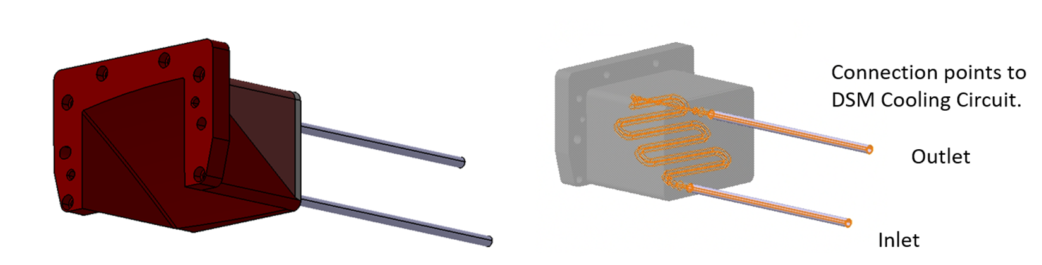
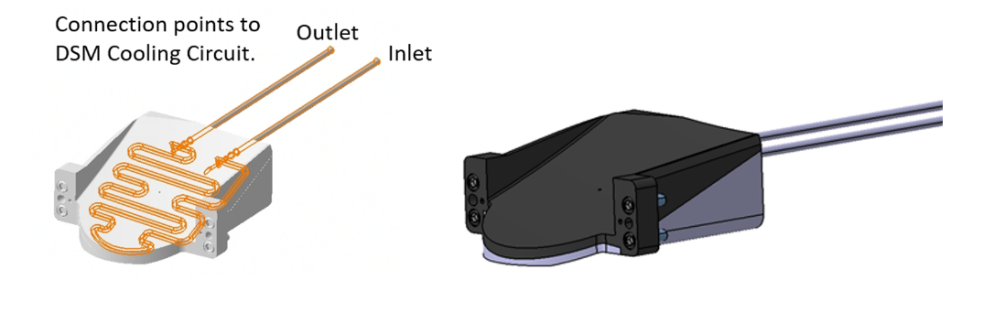
Size from 90 mm-350 mm length
Shape tolerance ±0.1 mm on the mirrors surface
The mirrors are expected to be accepted by means of fulfilling the following testing:
- Material properties
- Final Dimensional Control
- Baking and Outgassing
- Leak
- Pressure
- Dynamic Flow
- Coating Acceptance (if applicable)

Receiver line: Circular corrugated waveguides and mitre bends.
For the components and subassemblies that contain circular corrugated (CC) waveguides the inner geometry of the corrugation and coupling between CC parts are ideally defined and fully studied but not translated into Geometric Dimensioning and Tolerancing (GD&T) requirements. Design for manufacturing is needed regarding the inner part to meet the acceptance criteria based on functional requirements of Radio frequency (RF) transmission/losses.
Waveguides. Approx 10 m Ø31.75mm
Miter Bends 3 per transmission line
Sliding joints 2 per transmission line

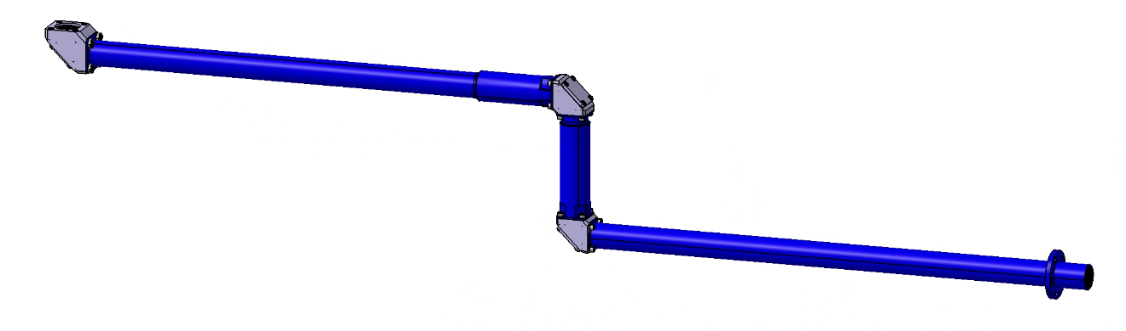

Launcher line: Split biased waveguide launcher miter bend and launcher bucket assembly.
As in the receiver line, the inner part of the RF components, the parts corresponding to circular corrugated overmoded Waveguides are defined at functional level and the acceptance criteria are subject to RF performance of the parts.
The double miter bend assembly contains corrugations in the inner part. The body and mirrors are actively cooled (mirrors joined by hipping and brazing).
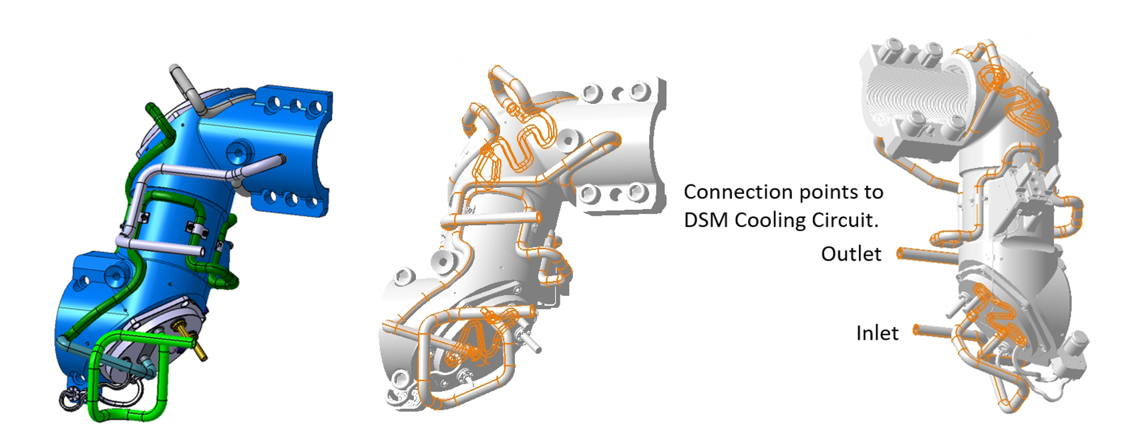
Overall mentions 300 x 120 mm
Acceptance criteria are provided by means of
- Material properties
- Final Dimensional Control
- Baking and Outgassing
- Leak
- Pressure
- Dynamic Flow
- Coating Acceptance
- Electrical Tests
- RF Testing
Split Biased Waveguide (SBWG) + Launcher Bucket Complex assembly, multi layered Waveguide (Ø88.9mm, L 1.200 mm) CuCrZr/AlN/SS 316L(N)-IG including cables and thermocouples. Actively cooled together with the Launcher Bucket assembly. Assembly and testing of SBWG is subject to comply with low voltage directive (CE marking).
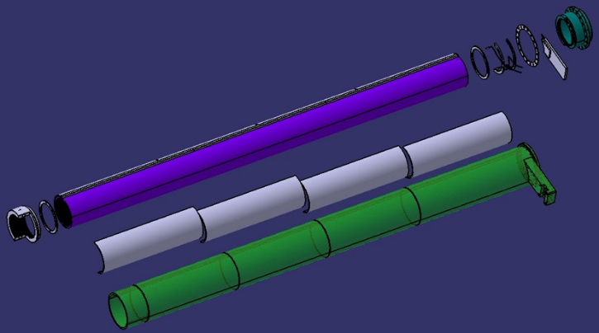
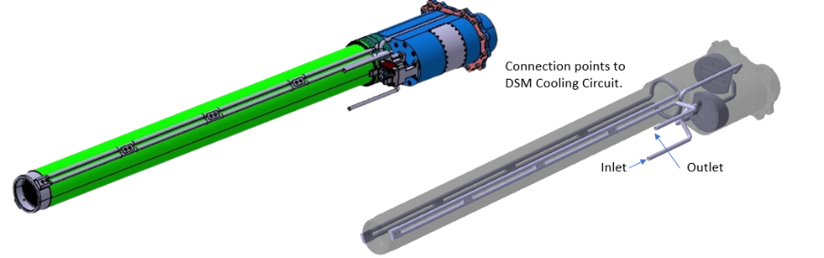
.

Acceptance criteria are provided by means of:
- Material properties
- Final Dimensional Control
- Baking and Outgassing
- Leak
- Pressure
- Dynamic Flow
- Coating Acceptance
- Electrical Tests
- RF Testing

Block M3
Complex machining including lid welding according to codes and standards and brazing operation to join the support block M3 to the Waveguides.
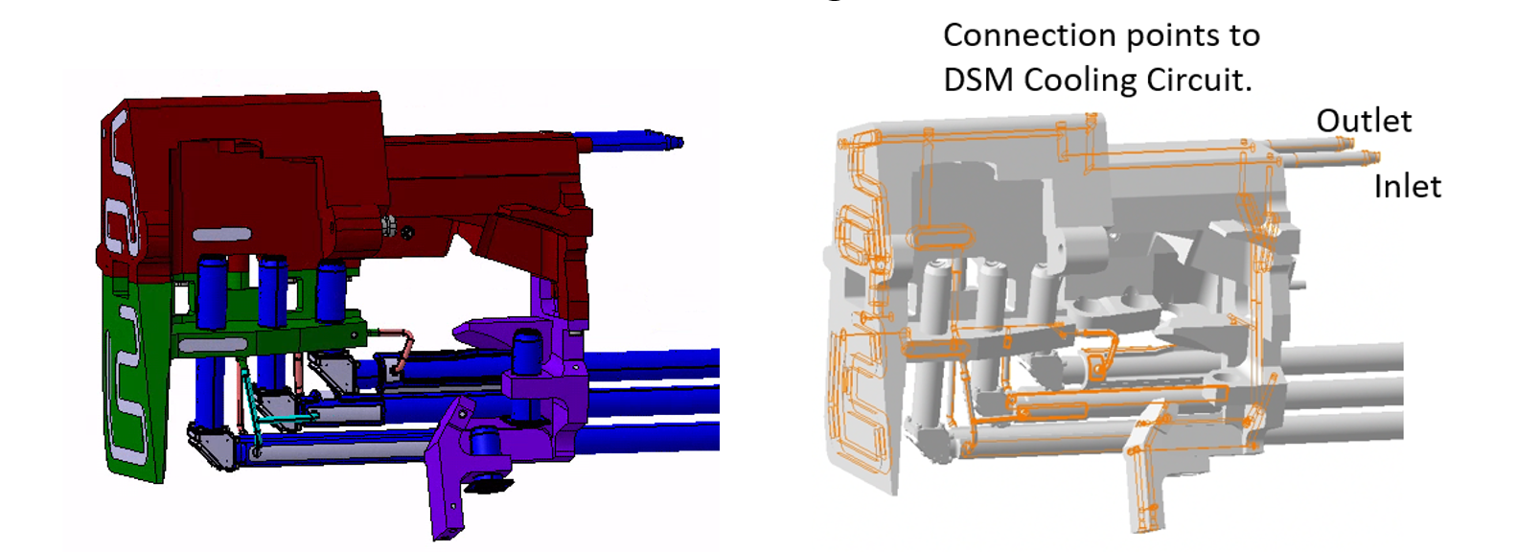
Overall dimensions 650 x 550 x 250 mm
Acceptance criteria are provided by means of:
- Material properties
- Final Dimensional Control
- Baking and Outgassing
- Leak
- Pressure
- Dynamic Flow

Published Market Survey
A worldwide Market Survey is published by Fusion For Energy on its Industry Portal in order to understand the interest of the market to enhance competition to provide the CTS to ITER.
Interested companies can answer to F4E questions here:
https://ec.europa.eu/eusurvey/runner/ITER_COLLECTIVE_THOMSON_SCATTERING_CTS

