F4E Architect Engineer II Market Survey Technical Note

Table of Contents
1 Introduction 2
1.1 F4E scope 2
1.2 BIPS scope 2
1.3 Description of F4E BIPS ongoing contracts 7
1.3.1 Support contracts 7
1.3.2 Tender Batch (TB) contracts 9
1.3.3 F4E – BIPS contracts planning 11
2 TECHNICAL SCOPE of Architect Engineer II (= TB25) 11
2.1 BASELINE: Architect Engineer II Core activities starting from 2025 till the end of the contract 11
2.2 OPTION related to the Baseline: Baseline scope extended by 1 year renewable 3 times 12
2.3 Other options 12
2.3.1 Option 1 - Execution Design activities for Building 14 1st plasma 12
2.3.2 Option 2 - Update of B14 CD & EXE to integrate Instrumentation & Control Optimization and IO expected changes on 1st plasma configuration 13
2.3.3 Option 3 - Designing additional PCRs after Mid 2024: Orphan topics pending IO clarification (IO DG letter), Optimizations, Others 13
2.3.4 Option 4. – Building B14 CD & EXE for new DT1 phase configuration 14
2.3.5 Option 5. - Building Integrator (functional analysis) 14
3 Estimated man-days 14

Introduction

F4E scope

The ITER project aims to build a fusion device twice the size of the largest current devices, with the goal of demonstrating the scientific and technical feasibility of fusion power. It is a joint project between the European Union, China, India, Japan, South Korea, the Russian Federation and the USA. The fusion reactor will be constructed in Europe, in Cadarache in the south of France.
The European Joint Undertaking for ITER and the Development of Fusion Energy or 'Fusion for Energy' is a type of European organization known as a Joint Undertaking created under the Euratom Treaty by a decision of the Council of the European Union.
'Fusion for Energy' has three main objectives:
- Providing the European contributions to the ITER international fusion energy research project being built in Cadarache, France;
- Providing European contributions to a number of joint projects with Japan that aim to accelerate the development of fusion - the "Broader Approach";
- Coordinating a program of activities to prepare for the first demonstration fusion reactors that can generate electricity (DEMO).

BIPS scope

The scope of BIPS (the Buildings, Infrastructure and Power Supplies - Project Team) is:
No. | Building/ Area | Status | Phases within the Architect Engineers (I, II, or III) Scope |  |  |  |  | Design Development by
 |  |  | Tender | Design | Construction | Closure | Post-Closure Works
11 | Tokamak Building | Civil Works: Completed  Building Services: Execution phase |  | X* | X | X |  | Civil completed  Building services M&E design : CD by TB04, ED by AE I  * Updates, changes by AE II
12 | Tokamak Complex Excavation Support Structure | Completed |  |  |  |  | X
13 | Assembly Building | Construction phase |  |  |  | X
14 | Tritium Building | Construction phase |  | X* | X | X |  | Civil completed  Building services M&E design : CD by AE I,  *ED by AE II and potential updates of CD
15 | RF Heating Building | Construction phase |  |  | X | X
17 | Cleaning Facility Building | Construction phase |  |  | X | X
19 | Seismic Isolation Basement | Completed |  |  |  |  | X
21 | Hot Cell Building | Not awarded | X | X | X | X |  | AE III to be confirmed
23 | Rad Waste Building | Not awarded | X | X | X | X |  | AE III to be confirmed
24 | Personnel Access Control Building | Not awarded | X | X | X | X |  | AE II to be confirmed
31 | SF6 Equipment Area | Design Phase |  |  | X | X
32 | Magnet Power Conversion Building 1 | Design Phase |  |  |  | X
33 | Magnet Power Conversion Building 2 | Completed |  |  |  | X
34 | NB Power supply Building | Design Phase |  |  | X | X
35 | Pulsed Power High Voltage Substation Area | Construction phase |  |  | X | X
36 | Main Alternating Current Distribution Building | Completed |  |  |  | X
37 | NB High Voltage Power Supply Building | Design Phase |  | X | X | X |  | Contractor (DD,CD,ED)
38 | Reactive Power Control Building | Completed |  |  |  | X
39 | Reactive Power Compensator Area | Completed |  |  |  | X
41 | Steady State Power High Voltage Substation | Construction phase |  |  | X | X
42 | Fuel Storage Tanks (EPS train A) | Not awarded | X | X | X | X |  | Contractor (DD,CD,ED)
43 | Fuel Storage Tanks (EPS train B) | Not awarded | X | X | X | X |  | Contractor (DD,CD,ED)
44 | Emergency Power Supply Building (train A) | Tender phase |  | X | X | X |  | Contractor (DD,CD,ED)
45 | Emergency Power Supply Building (train B) | Tender phase |  | X | X | X |  | Contractor (DD,CD,ED)
46 | Medium Voltage Distribution Building LC/ 1A | Tender phase |  | X | X | X |  | Contractor (DD,CD,ED)
47 | Medium Voltage Distribution Building LC/ 2B | Tender phase |  | X | X | X |  | Contractor (DD,CD,ED)
48 | R.T.E Switchyard Area | Completed
49 | R.T.E Control Building | Completed
51 | Cryoplant Compressor Building | Construction phase |  |  | X | X
52 | Cryoplant Coldbox Building | Construction phase |  |  | X | X
53 | Cryoplant Infrastructure | Construction phase |  |  | X | X
55 | PF Coil Building | Completed
61 | Site Services Building | Construction phase |  | X | X | X |  | Contractor  (CD,ED)
62 | Hot Water Bolier Buildings | Construction phase |  |  | X | X
67 | Cold Basin & Cooling Towers | Completed |  |  |  | X
68 | Cooling Water Pumping Station | Completed |  |  |  | X
69 | Heat Exchangers | Completed |  |  |  | X
71N | Control Building | Design Phase |  | X | X | X |  | Contractor (DD,CD,ED)
71S | Control Building (PIC) | Not awarded | X | X | X | X |  | Contractor (DD,CD,ED)
72 | Office Building | Completed
73 | Assembly Area | Completed
74 | Diagnostics Building | Construction phase |  | X | X | X
75 | FD and Switching Network Resistor Building | Design Phase |  | X | X | X |  | Contractor  (CD,ED)
MV01-MV02- MV03 | Medium Voltage Switchgear | Construction phase |  |  |  | X
MV04-MV05-MV06 | Medium Voltage Switchgear | Tender phase |  | X | X | X |  | Contractor (MI,A&ID)
LC03-LC05-LC06-LC10-LC11-LC12-LC14 | Load Centers | Construction phase |  |  | X | X
LC01-LC02- LC04-LC07-LC08- LC09 | Load Centers | Design Phase |  | X | X | X |  | Contractor (MI,A&ID)
LC13 | Load Centers | Not awarded | X | X | X | X |  | Contractor (MI,A&ID)

Note: The tender batches implementing the works on site have FIDIC contract type.
Where the scope is:
- For each building:
- The excavation works;
- The civil engineering work;
- The finishing work;
- The fire detection and protection;
- The HVAC system and piping;
- Liquid and gas;
- The handling;
- The shielding;
- The electrical power distribution
- Instrumentation and Control

- For the infrastructures:
- Roads
- Networks
- Special Foundations
- Outdoor Lighting
- Trenches and Galleries
- Drainage (Industrial, Precipitation,…)
- Fences, etc.

- For the power supply distribution (normal and emergency):
- High Voltage (400kV, 66kV)
- Medium Voltage (22kV, 6.6kV)
- Low Voltage
- DC distribution
- Diesel Generators
- Instrumentation and Control

Where the Design Phases are the following:
Contractor’s Design Phase | Contractor’s Documents Approval by the Engineer | Contractor’s Documents Approval by IO | Design Review | Type of Design Review
Conceptual Design | N/A | YES | YES | Conceptual Design Review (CDR)
Preliminary Design (PD) | YES | YES | YES | Preliminary Design Review (PDR)
Definition Design (DD) or Final Design (FD) | YES | YES | YES | Final Design Review (FDR)  Design Integration Review (DIR)
Construction Design (CD) | YES | YES | YES | Manufacturing Readiness Review (MRR)  Design Integration Review (DIR)
Execution Design (ED) | YES | NO | NO | N/A
Manufacturing Documentation  (Prior start Manufacturing; related to PBS61-62-63-65) | YES | YES | YES  (for SIC/IP) | Manufacturing Readiness Review (MRR)  Design Integration Review (DIR)
Manufacturing Intent (MI)  (Prior start Manufacturing; related to PBS41-43) | YES | YES | YES | Manufacturing Readiness Review (MRR)
Assembly and Installation Design (A&ID) (related to PBS41-43) | YES | YES | NO | N/A
Qualification Documentation
As built Documentation | YES | YES | NO | N/A

The Contracts between ITER and F4E, setting the rules for the follow-up by ITER of F4E’s procurements are called Procurement Arrangement (PA) and the PA’s related to the F4E SBPS scope are the following:

- 6.2.P2.EU.02 Architect Engineer Design ("AE") Services including all associated services and contracts for the ITER Buildings and Site Infrastructure.
- 6.2.P2.EU.05 Construction and Delivery of the ITER Buildings and Site Infrastructure

- 4.1.P1A.EU.00 / 4.1.P8B.EU.00 (4.1.P1A-8B.EU.01) Procurement Arrangement for the Detailed Design of the Steady State Electrical Network and the Pulsed Power Electrical Network
- 4.1.P1A-P8B.EU02 Installation and Commissioning of the ITER PBS 41. PP (Pulse Power) and PBS 43 Electrical Components
- 4.1.P8A.EU.01 Supply of the manufacturing, factory tests, inspections, delivery, & initial commissioning, associated with the ITER Emergency Power System (EPS)
- 4.1.P8C.EU.01 Supply of the manufacturing, factory tests, inspections, delivery, & initial commissioning, associated with the ITER “SSEN 22/6.6kV, Low Voltage components & Extra Low Voltage Components.”

The ITER PBS (Plant Breakdown Structure) subdivides the Project into packages. Within the SO’s scope of Services are the following six PBS’ described in the Reference and Applicable Documents:

- PBS41 Pulsed Power Electrical Network (PPEN), which supplies the magnets converters and the additional heating and current drive systems (Part P1 only; see table 3);
- PBS43 Steady State Electrical Network (SSEN), which supplies the auxiliaries systems, the Tokamak, the Cooling Water System. The Cryoplant and safety relevant loads are the main users of PBS43;
- PBS44 Cable Trays
- PBS61 Site;
- PBS62 Reinforced Concrete Buildings;
- PBS63 Steel Frame Buildings;
- PBS65 Liquid and Gas Distribution.

The following figure shows the Iter Site Master Plan with the layout and allocation of buildings and areas:

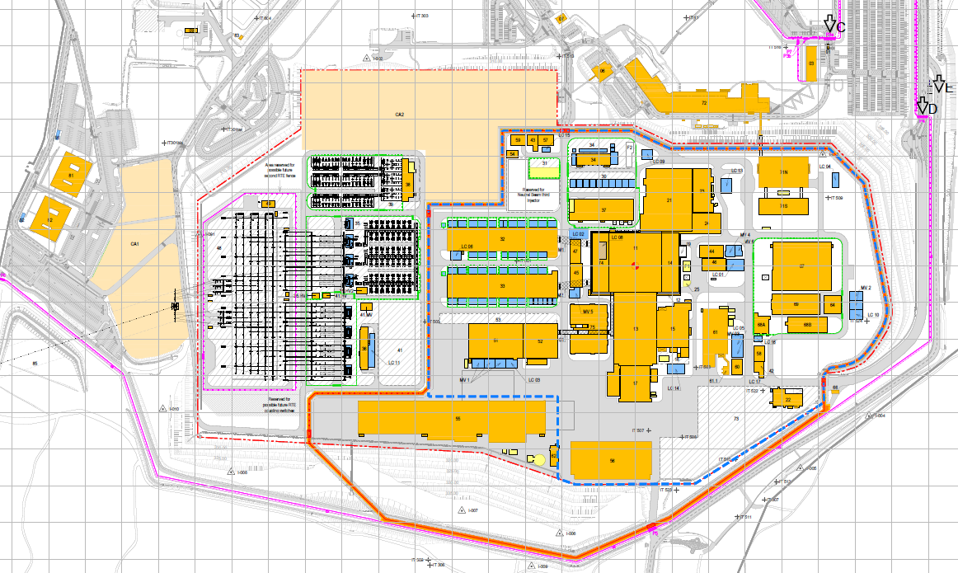
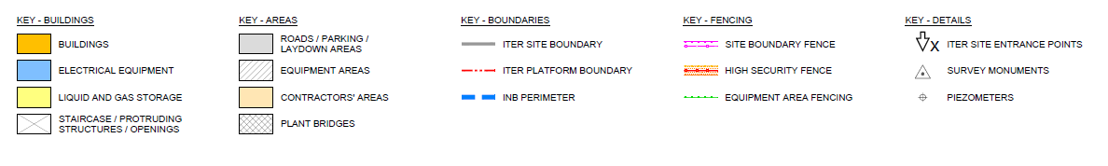

Description of F4E BIPS ongoing contracts

Support contracts

Most of the F4E Contracts are based in FIDIC Contract, where a Standard Contracting Environment is existing with the main figures and relationships are the following:
- Employer
- Engineer
- Designer
- Project Manager
- Contractor / subcontractors

There are also supporting functions:
- Resident Engineer Support Organization (RESO)
- Other client Supports as Legal Inspection, Health and Safety Coordination, Support to the Owner, etc…

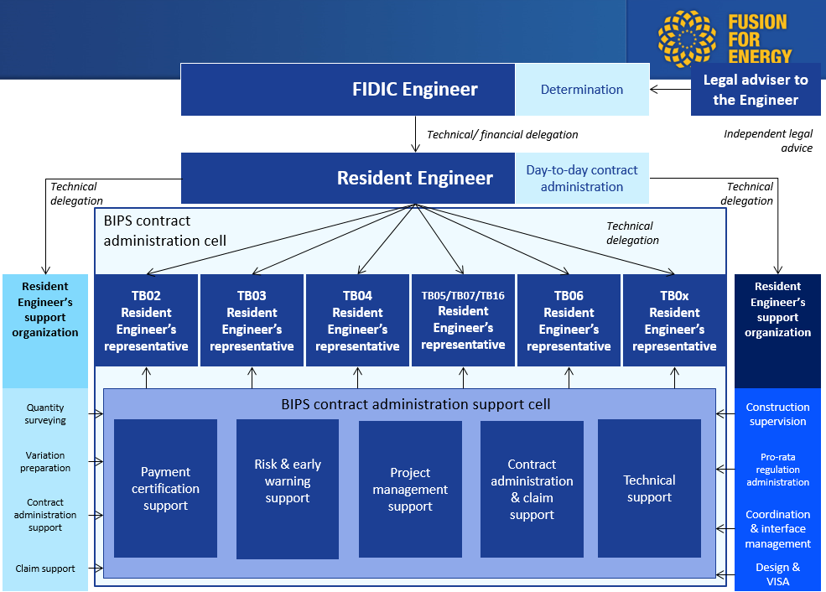
Main participants in the FIDIC Contracts
Nevertheless, other type of contracts, as Framework Contracts, NEC, Alliance, etc…) could be considered for the forthcoming tender batched that will be defined for each Call for Tender according to the F4E strategy.
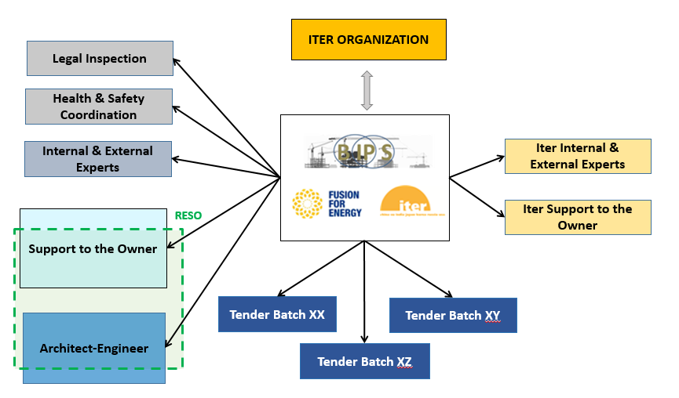
General Organization for BIPS scope.

Supplier shall consider four main support contracts:

Architect Engineer I (AE I)
The scope of the Architect Engineer services for ITER buildings and civil infrastructure contracts covers the provision of the architectural, civil engineering, building-related systems engineering design and follow-up services until 2025.

Support to the Owner (SO-I and SO-II)
The scope of this contract is the provision of civil engineering and construction consultancy services, the support to F4E in connection with the ITER Project. Specifically, together with F4E staff:
  - Technical review of design, specifications and offers
  - Design review
  - Document management
  - Support to definition/resolution of design interfaces through RFI (request for information) process.
  - Support to PCR preliminary technical analysis and interfaces analysis.
  - Follow-up of changes, instructions and safety requirements from ITER IO.
  - Support to preparation of Supplier Deviation Requests
  - Management of all contractor construction documents (quality, control plan, procedures etc… from start of works until taking over) in the different IT systems until final validation by IO and F4E.

Health and Safety Protection Coordination
The scope of the contract for the Health and Safety part refers to:
  - providing mandatory HSPC services for the worksite according to French law
  - providing additional health and safety advisory support to the contractor
  - track the implementation of collective protection

Legal Inspection Services
The Legal inspection scope is to ensure mandatory control required for an authorized company.

Tender Batch (TB) contracts
The table below shows the list of the contracts already signed and in progress (eleven of them) and to be signed (five of them) by the BIPS team for the execution of F4E contribution to ITER related to the subject matters. Some of the indicated forthcoming dates below are subject to potential modification.
TB02 | F4E-OPE-285 | Long Lead Mechanical Handling - Tokamak Cranes  Signed on 27/06/2013 | Ongoing
TB03 | F4E-OPE-286 | Main Civil & Finishing,  Signed on 20/12/2012 | Ongoing
TB06 | F4E-OPE-428 | HV Electrical Equipment  Signed in 16/09/2014 | Ongoing
TB09 |  | Construction of Hot Cell Facility (TB21), Radwaste (B23) & Personal Access Control Building (B24), Control Building PIC part (71)  Expected signature on Q1-2026 | To be Placed
TB11 | F4E-OFC-755 | Finishing works including TKC metal finishing works (civil, mechanical and electrical works)  Signed on 15/03/2018 | Ongoing
TB12 | F4E-OPE-688 | Design and Build of Buildings 34, 37, 71 and 75  Signed in 19/07/2019 | Ongoing
TB13 | F4E-OPE-1003 | Emergency Power Supplies Buildings (B44-47) with supply and installation of electrical components  Signed on 21/12/2020. | Ongoing
TB16 | F4E-OPE-636 | Site Infrastructure Works  Signed in 10/12/2015. | Ongoing
TB17 |  | Electrical Diesel Generators, Fuel Tanks and buildings 42, 43, 57-58  Expected signature on Q4-2027. | To be Placed
TB18 | F4E-OPE-996 | Civils and Finishing Tritium building above level L2  Signed on 18/12/2020. | On-going
TB19 | F4E-OPE-906 | Painting and Coating for Tokamak Complex  Signed in 30/04/2019. | Ongoing
TB20 | F4E-OPE-1099 | Door Installation and Metalworks Tritium building  Signed in December 2022 | Ongoing
TB21 | F4E-OMF-1107 | Framework contract for Electrical and mechanical works  Expected signature in Q1 2023. | Tender ongoing
TB22 | F4E-OMF-1168 | Framework contract for civil , metal works, finishing, retrofitting works  Expected signature in Q1 2023. | Tender ongoing
TB23 | pending | Tritium building services Nuclear Phase procurement  Expected signature in Q1 2026 | Forthcoming
TB24 | pending | IP Diesel Generator and corresponding buildings B59 and B60  Expected signature in Q4 2022 | Forthcoming
TB25 | F4E-OMF-1487 | Infrastructure, Facility Management Services & Building and Finishing Works  Expected signature in pending | Forthcoming

F4E – BIPS contracts planning
The below schedule is indicative and subject to potential modification.
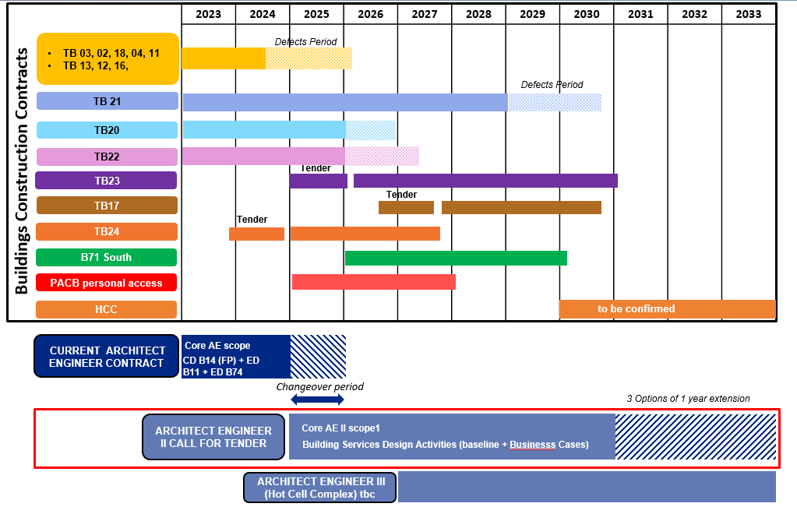

TECHNICAL SCOPE of Architect Engineer II (= TB25)

BASELINE: Architect Engineer II Core activities starting from 2025 till the end of the contract

The baseline scope called Core activities carried out from 2025 until end 2030 would be to supervise, to control & to coordinate ongoing construction Tender Batches (TBs) and to provide support engineering (Civil & M&E)
The activities can be breakdown in:
  - Site Support: Team gathering all types of expertise to be able to support F4E in every field of design activities Civil Work and Mechanical & Electrical for instance additional designs coming from ITER Project Change Request or from construction site need. Technical assistance on site / Offshore
  - Integration: Team in charge of CMM model management, support to the Contractors in the clash resolution process, mostly related to civil and services design activities, and in general in 3D integration works between all the systems.
  - Hotline: Specific team to manage rapidly the resolution of constructability issues for the Tokamak Complex Buildings.
  - Construction supervision and coordination: Team dedicated to control and supervise the execution of the works carried out by the contractors in the buildings (including services) and site infrastructure. In addition, they are in charge to follow the non-conformities related topics, test and commissioning of the works once finalized, and the control of the accesses on site.
  - Nuclear Safety and Quality Management: Team in charge of the safety and quality issues providing expertise within the Site Support Team and the Construction Team, and dealing with ASN (Autorité de Sûreté Nucléaire) related-topics and inspections
  - Project Management: Team including Building Delivery Managers for building, interconnecting and interfaces, Building Delivery Leaders for delivery steering, project administration and reporting.
  - Project Control: Dedicated team to project management office, including task as Site-Planning-Coordination, Configuration management, Variations management, Documentation management, etc.
The Tenderers would be invited to make an offer on the basis of yearly staffing plans and to provide also unit rates per profiles and seniority to allow, during contract implementation, adjustment of the staffing plans on yearly basis.

Option related to the Baseline: Baseline scope extended by 1 year renewable 3 times

The Option covers the extension of the baseline scope so called Core Activities by 1 year renewable 2 or 3 times (to be confirmed).

Other options

Option 1 - Execution Design activities for Building 14 1st plasma

The Architect Engineer shall provide the Execution Design (ED) for the electromechanical systems (HVAC, electrical, fire, I&C, liquid & gas, etc.) of the Building 14 for the 1st plasma phase.
The offer would be based on approved Building 14 Construction Design (CD) 1st plasma with a level of detail similar to the Execution Design (ED) package already delivered and approved for Building 11.
The Execution Design (ED) contains the detailed construction and/or manufacturing drawings, calculations and erection/construction procedures required to develop the construction/erection and test activities. It also includes the detailed manufacturing documentation required for the equipment and material procurement, and the manufacturing and factory test and inspection, unless otherwise defined in the Contract.

The Execution Design (ED) will include updated calculations only if necessary due to modifications or deviations to be implemented or due to a need for a justification to close remaining comments or chits from Construction Design phase.

Option 2 - Update of B14 CD & EXE to integrate Instrumentation & Control Optimization and IO expected changes on 1st plasma configuration

Following the ongoing Iter Re-baselining, the current 1st plasma phase configuration should evolve. It will require an update of the Building 14 1st plasma Construction Design (for the electromechanical systems (HVAC, electrical, fire, I&C, liquid & gas, etc.)) to extend, to complete the services according to new 1st plasma configuration. In addition, it will require an update of the Instrumentation & Control design.
The tenderer shall also include the additional design efforts in execution design that would result from the Construction Design (CD) update.
The offer would be based on the description of the evolution of the 1st plasma configuration and the approved Building 14 Construction Design 1st plasma.
The Construction Design (CD) is the detailed design that will be subject to a Manufacturer Readiness Review (MRR). It shall comply with all the F4E requirements, previous approved Design in Final Design Review (FDR) and the Forward Action Plans (FAP) coming from previous design phases.
The Construction Design (CD) shall be provided with at least the following:
- For electromechanical components: sizing of components according to detailed diagrams and substantiation from manufacturers (final calculations, detailed drawing, final data sheets ...), based on pre-sizing done in Definition Design.

Option 3 - Designing additional PCRs after Mid 2024: Orphan topics pending IO clarification (IO DG letter), Optimizations, Others

This option would cover the additional design coming from Project Change Requests (PCR) and in particular:
- Design updates related to new Iter re-baseline in particular for B74 & B11
- Design of Orphan topics pending IO clarification related to relief panels, air mixing system, ARL, mist antennas, Fire detection update to comply with EN54 & accept environmental conditions, Piezo valves, Stacks.
- Other Design efforts required by Project Change Request.
- I&C design updates and upgrades to integrate I&C optimization results.

The offer would be based on a list of profiles and man-hours defined by F4E with a cap.

Option 4. – Building B14 CD & EXE for new DT1 phase configuration

At this stage and for the scope of BIPS, the offer would be based on the remaining Construction Design (CD) and Execution Design (ED) for the electromechanical systems (HVAC, electrical, fire, I&C, liquid & gas, etc.) between Building 14 approved in Final Design Review (FDR) (all Iter phases) and the approved Construction Design and potentially the design made according to Business Case 2.

Option 5. - Building Integrator (functional analysis)

The offer would be based on 3 engineers (1 senior) skilled according to the need during 4 years to develop, and to complete:
- any necessary functional analysis and design update to ensure a proper functioning between all services, equipment (PBS 62,63,65,61,43) in F4E/BIPS scope design for the tokamak complex including load centers, pump houses, production of hot water, compressed air,…
- HAZOPs for PBS62 & 65 services
- Operation and Maintenance (O&M)

Estimated man-days

The estimated volume of the resulting contract is around 105,000 man-days for the Baseline and Optional scope.

