**MARKET SURVEY TECHNICAL NOTE:**

**FRAMEWORK CONTRACT**

**covering**

**FINAL DESIGN and SUPPORT TO THE OWNER**

**for the ITER**

**ISOTOPE SEPARATION SYSTEM**

**and**

**WATER DETRITIATION SYSTEM**

**Introduction**

The ITER project aims to build a fusion device, twice the size of the largest current devices, with the goal of demonstrating the scientific and technical feasibility of fusion power. It is a joint project between the European Union, China, India, Japan, South Korea, the Russian Federation, and the USA. ITER is being built in Europe, at Cadarache in the south of France.

Most of the components that make up the ITER project are to be manufactured by each of the participating countries and contributed in-kind through so-called Domestic Agencies including Fusion for Energy (F4E).

**F4E Market survey**

This Market Survey is performed in prevision of a Call for Tender to identify potentially relevant and interested companies, as well as to check some of F4E assumptions. Please note that the answers to the Market Survey are confidential and do not constitute any kind of commitments from your company.

This document is performed by Market Analysis Group and the F4E Fuel Cycle team. The purpose of the consultation is to identify potential European suppliers having a significant experience concerning the manufacturing of vacuum components, cryogenic equipment and hydrogen processing systems.

**Scope of work**

F4E plans to publish a procurement procedure for a Framework Contract covering the final design and support to the owner for the Isotope Separation and Water Distillation System of ITER.

|  | <<F4E D2W IDM Reference>> |  | **<<F4E D2W Call No>>** |
| --- | --- | --- | --- |
|  |  | | |
|  |  | | |

**Table of Contents**

1. overview of the ITER fuel cycle 4

2. Overview of the ITER Isotope Separation System (ISS) 5

2.1 Assembly overview of the cold columns with the valve box and the gas handling system 5

2.2 Component outline of the cold box 6

2.3 Component outline of the gas handling system 7

2.4 Component outline of the valve box 9

2.5 The cryogenic supply 9

2.6 Pressure equipment categorisation 9

2.7 Isotope Analysers 9

3. Water Detritiation System process background 10

3.1 WDS hardware outline 10

# 1. overview of the ITER fuel cycle

The ITER tokamak will be fuelled by streams of hydrogen (H) deuterium (D) and tritium (T). The ratios of these injections will be varied to optimize the performance, and they will be delivered to different systems in the tokamak. When the isotopes leave the tokamak, they will be mixed. To reuse them again in the fuel cycle of the ITER machine they need to be separated. The hydrogen Isotopes Separation System (ISS) has the main duty to perform the separation of the mixed isotope streams to allow their reuse for the plasma fuel cycle.

The ISS uses cryogenic distillation to separate the hydrogen isotopes. A demanding separation efficiency needs to be achieved to comply with the ITER functional requirements and the administrative limits for releasing tritium to the environment.

The separation of the mixed hydrogen isotopes is achieved by cryogenic distillation. The cryogenic distillation relies on the slight differences in boiling points (within 20 – 25 K range at atmospheric pressure) for the six hydrogen isotopologues, listed here in ascending order of boiling points: H2, HD, HT, D2, DT, T2. The slight differences in volatility of the species permit the separation of isotopes by multi-stage distillation with the heavier species (T2) at the bottom and most volatile species (H2) at the top of a distillation column.

To achieve the required separation efficiencies the ITER ISS contains 4 interconnected cryogenic distillation columns.

The ISS is a sub-system of the ITER tritium plant. The tritium plant consists of the tritium exhaust processing system (TEP), that receives all gases from the tokamak and proceeds them for ISS and for the gas Storage and Delivery System (SDS). The tritium plant contains further a Water Detritiation System (WDS) which is also directly connected to the ISS, see the block diagram in figure 1.

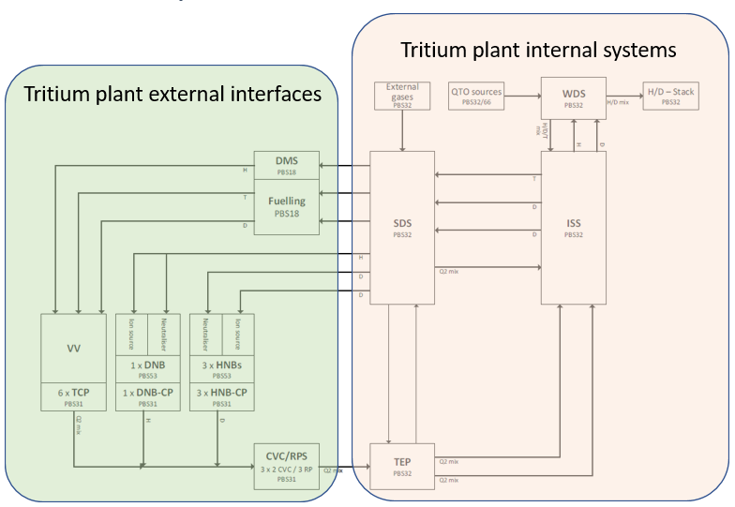

Figure 1: Fuel Cycle Block Diagram

# 2. Overview of the ITER Isotope Separation System (ISS)

The ISS cryogenic distillation (CD) columns are operated between 20-25K and installed in one common vacuum insulation chamber the “Cold box”. The cooling to the cryogenic temperatures is done by a dedicated helium refrigerator that is in the same building as the cold box and that is in the scope of procurement.

The second major sub-system is the ISS gas handling system that controls gas feeds into and out of the distillation columns and in between them. The gas handling system further connects to the clients within the tritium plant and contains analyses systems for the measurement and control of the hydrogen separation efficiency. The components of the gas handling system need to be located within glove boxes.

In case of loss of the cooling power the hydrogen inventory that is processed in the ISS at cryogenic temperatures need to be able to warm up and expand in a control way. For this purpose, the ISS is equipped with hard shell expansion tanks that can safely recover the hydrogen inventories that are released from the distillation columns in case they warm-up to above 30 K. A block diagram of the ISS is shown in figure 2.

The internal components in each of the ISS sub-systems will be outlined in the following sections.

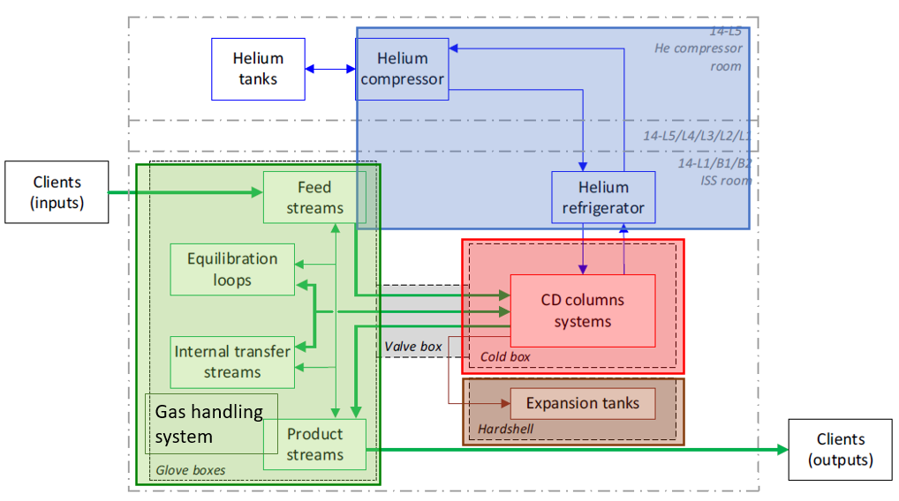

Figure 2: ISS sub-system block diagram

## Assembly overview of the cold columns with the valve box and the gas handling system

For the distillation process gas mixtures are exchanged in between distillation columns in the cold box or gas mixtures are chemically treated to enhance the efficiency of the process. In both cases the gases need to be warmed up to RT and cooled back to the cryogenic temperature of the distillation columns. In figure 3 a screenshot of a part of the overall ISS is depicted to visualize this with two of the four distillation columns. The heat exchangers need to be integrated in the cold box as they are operated at cryogenic temperatures.

Transfer pumps in between the columns or transfer pumps for chemical treatment of the gas mixtures are operated at RT and are part of the gas handling system. Almost all components of the gas handling system are in glove boxes to protect from the hazardous gases processed by ISS, see figure 2.

By the liquefaction of the gases in the distillation columns large inventories of hazardous gases result in the cold box during operation. In case of loss of the cryogenic cooling power these inventories need to be contained, and the gas handling system is separated from the cold box by 2 serial isolation valves on each line that connects the two systems. These valves are for the reason of confinement located in a valve box that provides the second barrier against a release of hazardous gases. The valves need scheduled maintenance, and the design of the valve box need to address a good access for personal equipped with protection suits to these 80-90 valves in the valve box.

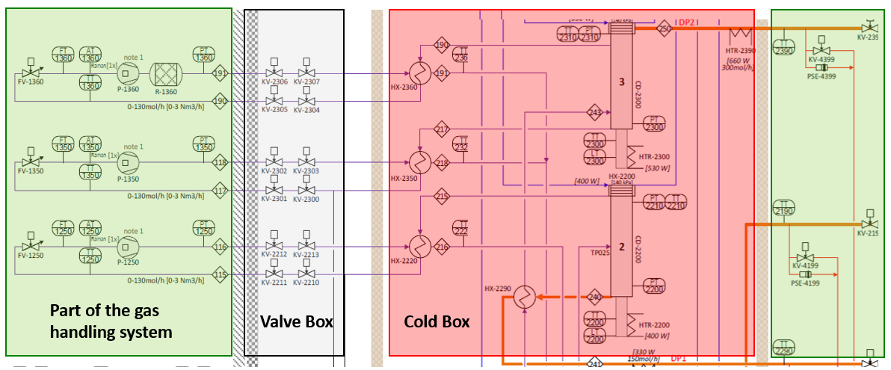

Figure 3: Assembly overview of a part of the ISS with the gas handling system at RT on the left (and outer right) the valve box with isolation valves in between the gas handling system and the cold box. The cold box contains the distillation columns (2 of 6 are shown) and the cryogenic heat exchangers for the processed gas.

## Component outline of the cold box

The cold box creates the vacuum insulation for all cryogenic equipment of the distillation process. There will be two cold boxes. Cold Box 1 will contain 4 distillation columns, each about 60 mm in diameter and 3-7 m in height. Cold box 2 will contain 2 distillation columns, each about 30 mm in diameter and 5-6 m in height. Every single distillation column will have its cryogenically cooled condenser unit at the top and an electrically heated reboiler unit at the bottom. The columns will be operated between 18-25 K with the lowest temperature at the condenser. Figure 4 depicts one of the cryogenic distillation columns of the preliminary Process Flow Diagram (PFD) with the required instrumentation and electrical equipment for it.

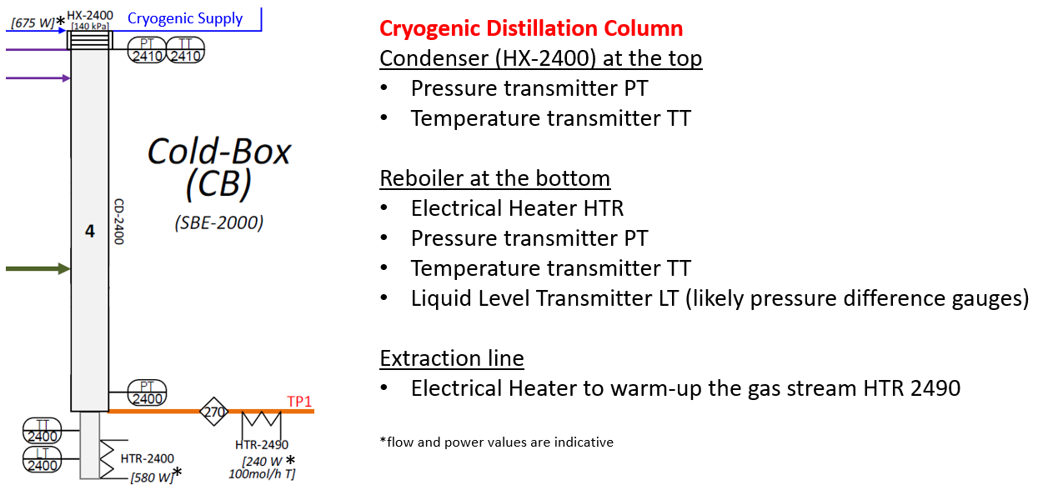

Figure 4: Cryogenic Distillation Column with the instrumentation

Any gas feed to the distillation columns will need to be cooled from RT to about 20-25K and any return feed from the distillation columns will need to be warmed up to RT again. There are eleven external process loops and each of them needs a counterflow heat exchanger (recuperator) to efficiently achieve the required process gas temperatures. These cryogenic heat exchangers used for the temperature accommodation of the hydrogen isotopes are located with the distillation columns in the cold box. Some of the heat exchangers will require additional cooling by the cryogenic refrigerator.

As presented in figure 4, instrumentation for the distillation columns are pressure and temperature transmitters. The temperature sensors are wall mounted on the piping and shall not be in the process volumes. The connection of pressure gauges to the process volumes shall be done by welding or VCR connections. An electrical heater is required on the reboiler and some electrical heaters are used for process gas lines that are directly connected to the gas handling or gas storage system.

The reboiler has a liquid hydrogen reservoir and the liquid inventory of hydrogen is measured by a pressure difference gauge. For this connection lines need to be routed from the reservoir of the reboiler (at cryogenic temperature) out of the cold box to the pressure gauges that are operated at ambient outside of the cold box.

## Component outline of the gas handling system

The gas handling system contains transfer pumps for the hydrogen isotope process gases. These pumps are used for the connection to the interfacing systems but also for the internal process loops. The internal process loops are the main part of the entire gas handling system. There are three transfer loops that are handling hydrogen gas in between the distillation columns and there are seven equilibration loops that are used to enhance the separation efficiency of the distillation process.

The PFD of a transfer loop is shown in figure 5. As mentioned before the process gas coming from and send back to the cold box needs to be thermalized what is done with the counterflow heat exchanger HX-2350. Supply and return line of the loop are equipped with isolation valves located in the valve box at RT (KV-…). The gas low can be controlled by the valve FV-1350 that is followed by the flow indicator FT-1350 and a connection to the gas analyser. The gas flow is provided by the metal bellows pump P-1350 that is followed by a pressure gauge PT-1350 prior the return to the cold box via the isolation valves.

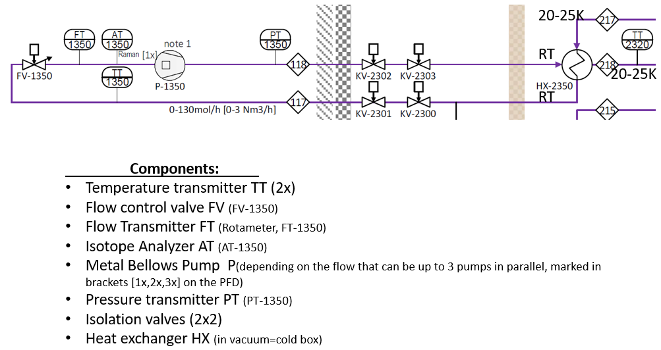

Figure 5: PFD of a transfer loop of the Isotope Separation System

The equilibration loop is mostly like a transfer loop, but it contains after the transfer pump P-1360 a catalyser (equilibrator, R-1360) to enhance the separation performance. All other components of the equilibration loop are similar as in the transfer loop.

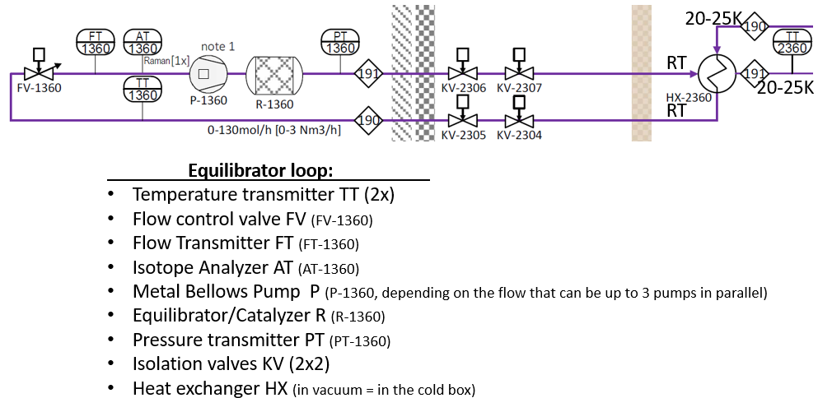

Figure 6: PFD of an equilibration loop of the Isotope Separation System

The gas handling system contains further four expansion tanks that recover the released hydrogen inventory from the distillation columns in case of a loss of cooling incident. These expansion tanks shall be double walled.

## Component outline of the valve box

The valve is functionally very simple as it just acts a secondary confinement for the hazardous gases that surrounds all isolation valves. Important for its design is to consider that the internal valves (about 70-80) require maintenance inspection and for this a good access for the maintenance activities that must be done by persons in protection suits.

## The cryogenic supply

It is assessed that the 6 distillation columns require a cooling power of 1.5 kW at a temperature of 18 K (600 W) and 20 K (900 W). The cooling fluid shall be pressurized helium gas. Possible solutions are a classical helium refrigerator using a water-cooled helium compressor at room temperature with a helium purification system to remove oil.

A second solution can be a Bryton Cycle based cryo-supply using high speed compressors immerged in helium and operated at cryogenic temperatures. These systems have been developed by industry focused on the use of hydrogen for aero, hydro and land mobility, but they are seen as well adequate as a cryogenic supply of the Isotope Separation System.

F4E is doing an analysis with support from industry of the optimum refrigerator solution for ISS.

## Pressure equipment categorisation

The operation pressure of the distillation columns is in the range of 1.1 to 1.4 bar-a and would not fall under the pressure equipment directives. But as in case of loss of coolant or insulation vacuum a pressure rise to about 8 bar cannot be avoided the design pressure of all the process equipment shall be 10 bar-a at a design temperature of 293 K. By this the components fall under the French nuclear pressure equipment directive (Equipment Sur Pression Nucléaire – ESPN).

ITER is a licensed nuclear facility as defined in the Decree of Authorisation of Creation of ITER-INB-174 and consequently IO, the Nuclear Operator, must comply with the French Order of 7th February 2012 establishing the general rules for licensed nuclear installations (INB-Order). As the Isotope Separate System is handling large amounts of tritium all pressure equipment is Nuclear Pressure Equipment and shall be procured assembled and manufactured in accordance with the French ESPN regulations.

## Isotope Analysers

The hydrogen analysers are very specific instruments developed in research institutions handling hydrogen and especially tritium (radioactive). It is foreseen that the procurement of the hydrogen analysers is under responsibility of the ITER Organization and the physical and functional interface to the gas handling system will be defined in detail for the PA.

# 3. Water Detritiation System process background

The Water Detritiation System (WDS) receives tritiated or potentially tritiated water from several clients spread across the whole ITER Site.

The WDS system can be split into two different sub-systems:

• WDS Core

• WDS RAP (Receive and Purification)

WDS Core represents the sum of all the equipment needed to recover tritium from the tritiated water effluents and return it to the Isotopic Separation System for further processing and re-integration in the Fuel Cycle.

WDS RAP represents the sum of all the equipment needed to store the tritiated water received from the various WDS clients and to prepare such effluents for processing by the WDS Core system.

During ITER operation, including maintenance campaigns, tritiated water will be generated by various sources and accumulated in amounts beyond the values that can be discharged within authorized limits. Water with the tritium concentrations from 3.7·1010 Bq/m3 up to 1.1∙1016 Bq/m³ will be processed in the Water Detritiation System (WDS) where it will be concentrated based on water distillation technology, which relies on the different boiling point of the different water isotopologues (Q2O).

The WDS shall have a capacity to process up to 60 kg/h of tritiated water and shall operate continuously 24 h a day, 7 days per week, minimum 8000 h/year.

The concentrated tritiated water from the water distillation column will be transferred to an exchange column that is based on the Liquid Phase Catalytic Exchange (LPCE). To this LPCE column the tritiated hydrogen isotopologues will be recovered from the concentrated stream of tritiated water and sent to the Isotope Separation System (ISS)

A Q2 stream (Q2 stands for all hydrogen isotopes), composed of high purity protium (< 1 ppm of tritium), supplied by ISS, will isotopically exchange with the concentrated tritiated water stream in the LPCE column. The tritium will migrate from the water molecule into the Q2 stream and will be substituted by migrating protium from the Q2 stream to the water. The tritium enriched Q2 stream will then be transferred back to ISS for tritium recovery, while the tritiated water stream (Q2O) will be fed back to the Distillation column.

## WDS hardware outline

The WDS RAP consists of Tanks and Pumps with the required interconnecting manifolds with valves and instrumentation.

In terms of size, the Emergency Tanks are the biggest ones with 100 m3 each. The feed Tanks are the next ones in size, with 20 m3 each, and then we have the Batch Tanks, with 12 m3 each. The smallest are the Effluent Tanks with 6,7 m3 each and the Drain Tank, with an unspecified volume so far but expected to be under the Effluent Tank. Pumping wise, there are two normal operation flowrates: 5 m3/h and 60 dm3/h. Recycle Pumps, and Effluent Pumps will have the former; Feed Pumps, UPU Pumps and Sampling Pumps[1] will have the latter.

The WDS Core is set up by a water distillation column of 1.2 m diameter and 48 m height. For the integration into the building the column is split into two 24 m heigh columns that are serially connected. The tritiated water that is accumulated at the bottom of this water distillation column is transferred to the LPCE column that has a diameter of 0.2 m and a height of about 6 m. To ensure that only hydrogen is transferred to ISS and no water a permeator is integrated at the interface to ISS.

Figure 1 - WDS main process components

1. To be confirmed