Technical Note for Market Survey on IFMIF-DONES Superconducting
RF Linac Cryomodules
In preparation for Call for Tender

Contents
1 INTRODUCTION TO IFMIF-DONES AND DEMO 2
2 DESCRIPTION OF THE IFMIF-DONES SUPERCONDUCTING RF LINAC CRYOMODULES 2
2.1 CRYOMODULES TECHNICAL DESCRIPTION 2
2.2 KEY RF PARAMETERS 4
3 SCOPE OF THE FUTURE CALL FOR TENDER 5
4 EXPECTED CAPABILITIES AND EXPERIENCE 6
5 MARKET SURVEY 6

Click here to enter text.

INTRODUCTION TO IFMIF-DONES AND DEMO
The IFMIF-DONES is a major international scientific infrastructure project aimed at supporting the development of fusion energy by testing and qualifying materials that will be used in future fusion reactors, particularly the DEMO reactor (the demonstration fusion power plant that will follow ITER). As a user facility, during its 30 years lifetime, IFMIF-DONES is expected to achieve a high inherent availability of 75% – which translated to the Accelerator Systems corresponds to an inherent availability of 87%. As of the writing of this document, it is a joint project between Spain, the European Union and Croatia. IFMIF-DONES is currently under late-stage planning phase for its construction at Escúzar site in Granda, Spain. Fusion for Energy is leading the European Union contribution to IFMIF-DONES.

DESCRIPTION OF THE IFMIF-DONES SUPERCONDUCTING RF LINAC CRYOMODULES

CRYOMODULES TECHNICAL DESCRIPTION
The IFMIF-DONES superconducting RF Linac is composed of five cryomodules that accelerate a 125-mA 175-MHz continuous-wave deuteron beam from 5 MeV to 40 MeV. The SRF Linac receives deuterons at 5 MeV from the accelerator front end, which includes an injector, a Radio Frequency Quadrupole (RFQ), and a Medium-Energy Beam Transport (MEBT) section. After acceleration up to 40 MeV in the cryomodules, the deuterons are sent to the High-Energy Beam Transport (HEBT) section, which transports and shapes the beam to either a Beam Dump (for machine setup and fine tuning) or to a Lithium Target (for the production of a high neutron flux capable of irradiating materials at a rate comparable to the DEMO fusion reactor conditions).

Figure 1: Functional location of the cryomodules in the IFMIF-DONES accelerator

Each cryomodule consists of a string alternating Half-Wave Resonator (HWR) superconducting cavities and superconducting solenoid magnets (hereafter referred to as cavity string) inside a cryostat. Two different types of HWR cavities are available to adjust to the increasing relativistic beta of the beam. Cryomodule 1 is composed of 8 low-beta cavities and 8 solenoids. Cryomodule 2 is composed of 11 low-beta cavities and 6 solenoids. Cryomodules 3 to 5 are composed of 9 high-beta cavities and 5 solenoids. The space between each pair of consecutive cryomodules is connected by means of a short warm section which contributes to sustaining the ultra-High Vacuum (UHV) conditions required for beam transport and which allocates room for beam diagnostics.
Cryomodule | CM1 | CM2 | CM3 | CM4 | CM5
HWR beta  optimum | Low  0.116 | Low  0.116 | High  0.179 | High  0.179 | High  0.179
Elementary sequence | 1 solenoid +  1 cavity | 1 solenoid +  2 cavities | 1 solenoid +  2 cavities | 1 solenoid +  2 cavities | 1 solenoid +  2 cavities
Number of elementary  sequences | 8 | 5 | 4 | 4 | 4
Inlet section | none | 1 solenoid +  1 cavity | 1 solenoid +  1 cavity | 1 solenoid +  1 cavity | 1 solenoid +  1 cavity
Total number of cavities | 8 | 11 | 9 | 9 | 9
Total number of solenoids | 8 | 6 | 5 | 5 | 5
Output energy (MeV) | 8.3 | 13.9 | 21.3 | 30.3 | 40
Table 1: Configuration of the IFMIF-DONES superconducting RF Linac

Each of the cavities and solenoids is enclosed in a helium tank. The cavities are equipped with a compressive frequency tuning system. Due to spatial constraints, two pairs of racetrack coils for horizontal/vertical beam steering are embedded within each solenoid package. Beam diagnostics such as Cold Beam Position Monitors (CBPMs) and micro-Loss Monitors (µLoMs) are attached to the helium tank of the solenoids. RF power is coupled into the cavities by means of an antenna equipped with a room-temperature RF window and a cooled outer conductor that sustains the gradient from the cryogenic temperature of the cavity string to the room temperature of the RF window. The solenoids are driven by means of helium vapour cooled current leads. The cold mass comprises the cavity string together with its associated cryogenic piping and a phase separator.
The cryomodules are designed to be top loaded with the cold mass and the magnetic and thermal shields hanging off the vacuum vessel top lid. The vacuum vessel tub has a support system with alignment features. Other subsystems include instrumentation and external equipment.
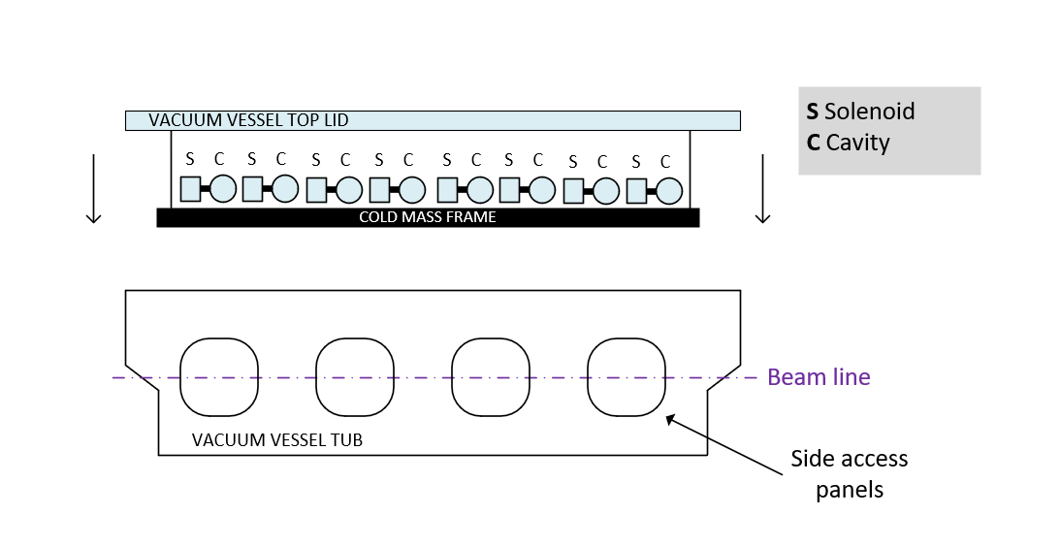Figure 2: Simplified view of the cryomodule with top loading.
The cold mass configuration would correspond to CM1.
Not represented in the figure: Magnetic shield, thermal shield, piping,
couplers, helium phase separator, current leads and instrumentation.

Magnitude | Value | Units | Maturity
Length | 6.1 to 7.0 | m | Reference design
Width | 2.2 | m | Reference design
Height | 3.2 | m | Reference design, including feet.
Mass | 17000 | kg | estimate
Table 2: Key data for all cryomodules

KEY RF PARAMETERS
The SRF performance metrics from the reference design are described in Table 4.

 |  | Low-beta  cryomodule | High-beta cryomodule
Cavity | Beta opt | 0.115 | 0.175
 | Nominal Accelerating Field (E_{acc_nom}) | 4.5 MV/m | 4.5 MV/m
 | Q₀ @ E_{acc_nom} | 5x10⁸ | 10⁹
 | Frequency at cold during vertical test (cavity untuned, no power coupler) | 175.016  - 175.060 MHz | 175.016  - 175.060 MHz
 | Tuning Range | - 50 kHz | - 50 kHz
 | Loaded cavity bandwidth | 2.7 kHz | -
 | Working Temperature | 4.45 K
Power Coupler | Transmitted Power | 100 kW CW | 200 kW CW
 | Q_{ext} | 6.3x10⁴ | -
Solenoid magnet | Peak magnetic field B_{z} on axis | 6 T
 | On-axis integrated B_{z} field | 1.1 T.m
 | Steerers on-axis integrated field | 3.5 mT.m
 | Fringe field on cavity flange | 20 mT
Table 3: Key SRF parameters for the low- and high-beta cavities and solenoid magnets.

SCOPE OF THE FUTURE CALL FOR TENDER
The provisional scope of the contract may include the following hardware deliverables:
- Two low-beta and three high-beta cryomodule assemblies, and four warm sections
- Diagnostics, instrumentation, and control devices to operate the machine
- Local instrumentation and control system including: controls cabinets, controls software, human-machine interface, and computers
- Packaging including a vibrational absorbing transport frame
The provisional scope of the contract may include the following activities:
- Design activities to achieve a technical proposal that is compliant with the technical requirements of the system.
- Engineering analyses of equipment and systems, including an assessment of the manufacturing and assembly feasibility and potential optimization of the design.
- Implementation of safety analyses in line with the IFMIF-DONES plant requirements.
- Optimization of the Reliability, Availability, Maintenance, and Inspectability (RAMI) of the system and development of a maintenance plan.
- Procurement of raw materials and components.
- Manufacturing design and preparation – including, if required, the production of prototypes and mock-ups to validate and qualify the proposed design and the manufacturing process.
- Series production, acceptance tests of subsystems, and factory acceptance tests (FATs) of the validated design.
- Shipment and delivery of the system to the IFMIF-DONES site in Escúzar (Granada, Spain), including the design and construction of a vibration absorbing transport frame to ship the cryomodules.
- On-site assembly, integration, check-out, commissioning, and Site Acceptance Testing of the system at IFMIF-DONES site in Escúzar (Granada, Spain).
- For each phase of the system lifecycle within the scope of the supply: preparation and production of detailed documentation and exhaustive data packages for review and acceptance with the participation of experts from F4E, IFMIF-DONES and external experts.

The activities mentioned in the list above shall be implemented according to a strict and high-standard Project and Quality Management Plan (PQMP).
Alongside the main requirements, F4E will provide reference design documentation for the subcomponents.

EXPECTED CAPABILITIES AND EXPERIENCE
The potential supplier is expected to have demonstrated experience in:
- Design, manufacturing and testing of superconducting particle accelerator cavities, superconducting magnets, and cryomodules.
- Expert knowledge of material properties, material procurement and material processing of Niobium and Niobium alloys (machining, deep drawing, EB welding, vacuum brazing, surface chemistry, hydrogen degassing heat treatment).
- Design, manufacturing, qualification, and conditioning of RF power couplers.
- Manufacturing of vacuum vessel, thermal shield and magnetic shield, including manufacturing capability of laying multi-layer insulation inside a vacuum space.
- Manufacturing of cryogenic components for helium circuits.
- Manufacturing and assembly of vacuum assemblies, with stringent leak tightness requirements at component level (q < 1.10⁻¹¹ mbar·l·s⁻¹).
- Manufacturing and assembly stainless steel and titanium structures.
- Welding technologies of stainless steels and titanium with vacuum requirements.
- Manufacturing of cryogenic component assemblies including complex assembly sequences and use of low permeability stainless steel.
- Clean environment assembly procedures for UHV components – clean room ISO class 5 or better.
- Non-destructive examination such as RT and UT (complying with 100% volumetric inspection of welds).
- Metrology resources to perform cavities alignment with the cold mass ahead of assembly.
- Testing resources and capacities to perform the required acceptance tests of SRF Linac subsystems and the FATs of assembled cryomodules.
- Manufacturing engineering and quality assurance and control activities required during manufacturing, assembly and testing.
- Procurement of control systems for: cryogenic instrumentation, superconducting magnets, tuner motors and beamline instrumentation.
- Demonstrated experience in EPICS-controls.

MARKET SURVEY
To establish an optimum contract strategy, F4E needs to develop its understanding of the market with a comprehensive list of possible interested EU suppliers.
In the frame of the Market Survey, interested suppliers are invited to submit the requested information. This information will be visible to F4E only and will not be communicated to other parties, except if agreed upon by the respondent(s).
Please answer to the F4E Market Survey by clicking on this LINK.

IFMIF-DONES stands for International Fusion Materials Irradiation Facility - DEMO Oriented Neutron Source.
DEMO stands for the future DEMOnstration Nuclear plant.
ITER stands for International Thermonuclear Experimental Reactor.

